ARDUINO
Arduino Uno is a microcontroller board based on 8-bit ATmega328P microcontroller. Along with ATmega328P, it consists other components such as crystal oscillator, serial communication, voltage regulator, etc. to support the microcontroller. Arduino Uno has 14 digital input/output pins (out of which 6 can be used as PWM outputs), 6 analog input pins, a USB connection, A Power barrel jack, an ICSP header and a reset button.
The ATmega328 microcontroller contains 32 general purpose working registers. As shown in the below figure these registers are directly connected to ALU. Two registers can carry one single instruction consequently in one clock cycle.
Specifications:
Microcontroller | ATmega328P – 8 bit AVR family microcontroller
Operating Voltage | 5V
RecommendedInput Voltage | 7-12V
Input Voltage Limits | 6-20V
Analog Input Pins | 6 (A0 – A5)
Digital I/O Pins | 14 (Out of which 6 provide PWM output)
DC Current on I/O Pins | 40 Ma
DC Current on 3.3V Pin | 50 Ma
Flash Memory | 32 KB (0.5 KB is used for Boot loader)
SRAM | 2 KB
EEPROM | 1 KB
Frequency (Clock Speed) | 16 MHz

Table: Atmega328 specifications
ARDUINO:
Arduino is a prototype platform (open-source) based on an easy-to-use hardware and software. It consists of a circuit board, which can be programmed (referred to as a microcontroller) and a ready-made software called Arduino IDE (Integrated Development Environment), which is used to write and upload the computer code to the physical board.
The key features are −
Arduino boards are able to read analog or digital input signals from different sensors and turn it into an output such as activating a motor, turning LED on/off, connect to the cloud and many other actions.
You can control your board functions by sending a set of instructions to the microcontroller on the board via Arduino IDE (referred to as uploading software).
Unlike most previous programmable circuit boards, Arduino does not need an extra piece of hardware (called a programmer) in order to load a new code onto the board. You can simply use a USB cable.
Additionally, the Arduino IDE uses a simplified version of C++, making it easier to learn to program.
Finally, Arduino provides a standard form factor that breaks the functions of the micro-controller into a more accessible package.
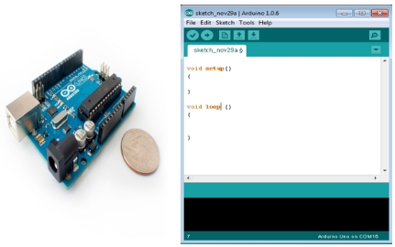
Fig: Arduino Uno

BOARD TYPES-
Various kinds of Arduino boards are available depending on different microcontrollers used. However, all Arduino boards have one thing in common: they are programed through the Arduino IDE.
The differences are based on the number of inputs and outputs (the number of sensors, LEDs, and buttons you can use on a single board), speed, operating voltage, form factor etc. Some boards are designed to be embedded and have no programming interface (hardware), which you would need to buy separately. Some can run directly from a 3.7V battery, others need at least 5V.
Here is a list of different Arduino boards available.
Table- Arduino boards based on ATMEGA328 microcontroller
Board Name | Operating Volt | Clock Speed | Digital i/o | Analog Inputs | PWM | UART | Programming Interface
Arduino Uno R3 | 5V | 16MHz | 14 | 6 | 6 | 1 | USB via ATMega16U2
Arduino Uno R3 SMD | 5V | 16MHz | 14 | 6 | 6 | 1 | USB via ATMega 16U2
Red Board | 5V | 16MHz | 14 | 6 | 6 | 1 | USB via FTDI
Arduino Pro 3.3v/8 MHz | 3.3V | 8MHz | 14 | 6 | 6 | 1 | FTDI-Compatible Header
Arduino Pro 5V/16MHz | 5V | 16MHz | 14 | 6 | 6 | 1 | FTDI-Compatible Header
Arduino mini 05 | 5V | 16MHz | 14 | 8 | 6 | 1 | FTDI-Compatible Header
Arduino Pro mini 3.3v/8mhz | 3.3V | 8MHz | 14 | 8 | 6 | 1 | FTDI-Compatible Header
Arduino Pro mini 5v/16mhz | 5V | 16MHz | 14 | 8 | 6 | 1 | FTDI-Compatible Header
Arduino Ethernet | 5V | 16MHz | 14 | 6 | 6 | 1 | FTDI-Compatible Header
Arduino Fio | 3.3V | 8MHz | 14 | 8 | 6 | 1 | FTDI-Compatible Header
LilyPad Arduino 328 main board | 3.3V | 8MHz | 14 | 6 | 6 | 1 | FTDI-Compati
LilyPad Arduino simple board | 3.3V | 8MHz | 9 | 4 | 5 | 0 | FTDI-Compatible Header
Table: Arduino boards based on ATMEGA32u4 microcontroller
BOARD DESCRIPTION:
In this chapter, we will learn about the different components on the Arduino board. We will study the Arduino UNO board because it is the most popular board in the Arduino board family. In addition, it is the best board to get started with electronics and coding. Some boards look a bit different from the one given below, but most Arduinos have majority of these components in common.
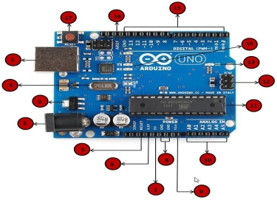
1 | Power USB  Arduino board can be powered by using the USB cable from your computer. All you need to do is connect the USB cable to the USB connection (1).
2 | Power (Barrel Jack)  Arduino boards can be powered directly from the AC mains power supply by connecting it to the Barrel Jack (2).
3 | Voltage Regulator  The function of the voltage regulator is to control the voltage given to the Arduino board and stabilize the DC voltages used by the processor and other elements.
4 | Crystal Oscillator  The crystal oscillator helps Arduino in dealing with time issues. How does Arduino calculate time? The answer is, by using the crystal oscillator. The number printed on top of the Arduino crystal is 16.000H9H. It tells us that the frequency is 16,000,000 Hertz or 16 MHz.
5, 17 | Arduino Reset  You can reset your Arduino board, i.e., start your program from the beginning. You can reset the UNO board in two ways. First, by using the reset button (17) on the board. Second, you can connect an external reset button to the Arduino pin labelled RESET (5).
6, 7, 8, 9 | Pins (3.3, 5, GND, Vin)  3.3V (6) − Supply 3.3 output volt  5V (7) − Supply 5 output volt  Most of the components used with Arduino board works fine with 3.3 volt and 5 volt.  GND (8)(Ground) − There are several GND pins on the Arduino, any of which can be used to ground your circuit.  Vin (9) − This pin also can be used to power the Arduino board from an external power source, like AC mains power supply.
10 | Analog pins  The Arduino UNO board has six analog input pins A0 through A5. These pins can read the signal from an analog sensor like the humidity sensor or temperature sensor and convert it into a digital value that can be read by the microprocessor.
11 | Main microcontroller  Each Arduino board has its own microcontroller (11). You can assume it as the brain of your board. The main IC (integrated circuit) on the Arduino is slightly different from board to board. The microcontrollers are usually of the ATMEL Company. You must know what IC your board has before loading up a new program from the Arduino IDE. This information is available on the top of the IC. For more details about the IC construction and functions, you can refer to the data sheet.
12 | ICSP pin  Mostly, ICSP (12) is an AVR, a tiny programming header for the Arduino consisting of MOSI, MISO, SCK, RESET, VCC, and GND. It is often referred to as an SPI (Serial Peripheral Interface), which could be considered as an "expansion" of the output. Actually, you are slaving the output device to the master of the SPI bus.
13 | Power LED indicator  This LED should light up when you plug your Arduino into a power source to indicate that your board is powered up correctly. If this light does not turn on, then there is something wrong with the connection.
14 | TX and RX LEDs  On your board, you will find two labels: TX (transmit) and RX (receive). They appear in two places on the Arduino UNO board. First, at the digital pins 0 and 1, to indicate the pins responsible for serial communication. Second, the TX and RX led (13). The TX led flashes with different speed while sending the serial data. The speed of flashing depends on the baud rate used by the board. RX flashes during the receiving process.
15 | Digital I/O  The Arduino UNO board has 14 digital I/O pins (15) (of which 6 provide PWM (Pulse Width Modulation) output. These pins can be configured to work as input digital pins to read logic values (0 or 1) or as digital output pins to drive different modules like LEDs, relays, etc. The pins labeled “~” can be used to generate PWM.
16 | AREF  AREF stands for Analog Reference. It is sometimes, used to set an external reference voltage (between 0 and 5 Volts) as the upper limit for the analog input pins.

ARDUINO FAMILY
Arduino makes several different boards, each with different capabilities. In addition, part of being open source hardware means that others can modify and produce derivatives of Arduino boards that provide even more form factors and functionality. If you're not sure which one is right for your project , check this guide for some helpful hints. Here are a few options that are well suited to someone new to the world of Arduino.
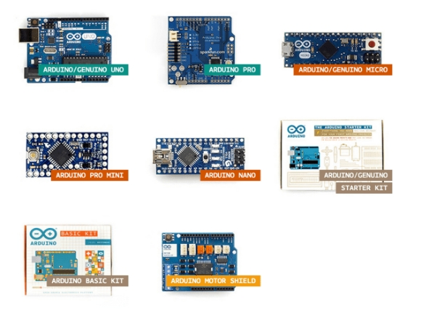
Fig: Arduino Family
PIN DESCRIPTION OF ATMEGA328
ADVANTAGES OF ARDUINO
It is cheap
It comes with an open supply hardware feature that permits users to develop their own kit
The software of the Arduino is well-suited with all kinds of in operation systems like Linux, Windows, and Macintosh, etc.
It also comes with open supply software system feature that permits tough software system developers to use the Arduino code to merge with the prevailing programming language libraries and may be extended and changed.
For beginners, it is very simple to use.
APPLICATIONS
ATMEGA328 is commonly used in many projects and autonomous systems where a simple, low- powered, low- cost microcontroller is needed. Perhaps the most common implementation of this chip is on the popular Arduino development platform, namely the Arduino UNO and Arduino Nano model
POWER SUPPLY UNIT
The power supplies are designed to convert high voltage AC mains electricity to a suitable low voltage supply for electronic circuits and other devices. A power supply can by broken down into a series of blocks, each of which performs a particular function. A d.c power supply which maintains the output voltage constant irrespective of a.c mains fluctuations or load variations is known as “Regulated D.C Power Supply”.
4.1.1 BLOCK DIAGRAM OF POWER SUPPLY:

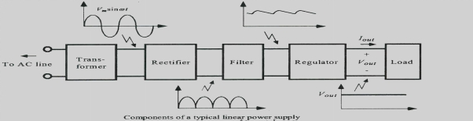
Fig: Block Diagram of Power Supply

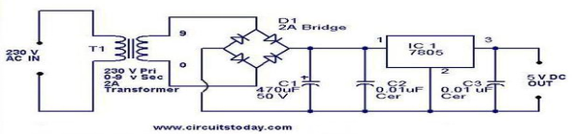
Fig(A): Schematic Diagram of Power Supply

DESCRIPTION OF POWER SUPPLY:
A power supply is a component that supplies power to at least one electric load. Typically, it converts one type of electrical power to another, but it may also convert a a different form of energy – such as solar, mechanical, or chemical - into electrical energy.
A power supply provides components with electric power. The term usually pertains to devices integrated within the component being powered. For example, computer power supplies convert AC current to DC current and are generally located at the rear of the computer case, along with at least one fan. A power supply is also known as a power supply unit, power brick or power adapter.
POWER SUPPLY UNIT
This is a 3.3V/5V MB102 Breadboard Power Supply Module which provides a dual 5 V and 3.3 V power rails and has a multi-purpose female USB socket.
The 3.3V/5V MB102 Breadboard Power Supply Module securely fits in a standard 400 or 800 tie points breadboard it also features reverse polarity protection, the module can take 6.5V to 12V input and can produce 3.3V and +5V.
The module can also output 5V on USB connector or input through the USB connector. It’s a must-have product for experimenters those have to test/prototype electronic circuits on the breadboard.

Features :
Breadboard power supply module, compatible with 5V, 3.3V.
Apply to MB102 breadboard
Fluctuation two road independent control can switch over to 0 V, 3.3 V, 5 V
On-board two groups of 3.3V, 5V DC output plug pin, convenient external lead use.
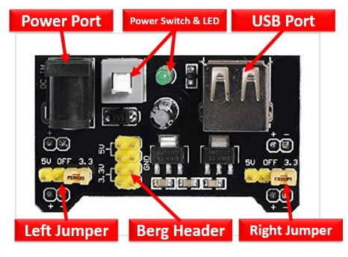

EMBEDDED SOFTWARE
Arduino is an open-source prototyping platform based on easy-to-use hardware and software. Arduino boards are able to read inputs - light on a sensor, a finger on a button, or a Twitter message - and turn it into an output - activating a motor, turning on an LED, publishing something online. You can tell your board what to do by sending a set of instructions to the microcontroller on the board. To do so you use the Arduino programming language (based on Wiring), and the Arduino Software (IDE), based on Processing. Over the years Arduino has been the brain of thousands of projects, from everyday objects to complex scientific instruments. A worldwide community of makers - students, hobbyists, artists, programmers, and professionals
- has gathered around this open-source platform, their contributions have added up to an incredible amount of accessible knowledge that can be of great help to novices and experts alike. Arduino was born at the Ivrea Interaction Design Institute as an easy tool for fast prototyping, aimed at students without a background in electronics and programming. As soon as it reached a wider community, the Arduino board started changing to adapt to new needs and challenges, differentiating its offer from simple 8-bit boards to products for IoT applications, wearable, 3D printing, and embedded environments. All Arduino boards are completely open- source, empowering users to build them independently and eventually adapt them to their particular needs. The software, too, is open-source, and it is growing through the contributions of users worldwide.
WHY ARDUINO?
Thanks to its simple and accessible user experience, Arduino has been used in thousands of different projects and applications. The Arduino software is easy-to-use for beginners, yet flexible enough for advanced users. It runs on Mac, Windows, and Linux. Teachers and students use it to build low cost scientific instruments, to prove chemistry and physics principles, or to get started with programming and robotics. Designers and architects build interactive prototypes, musicians and artists use it for installations and to experiment with new musical instruments. Makers, of course, use it to build many of the projects exhibited at the Maker Faire, for example. Arduino is a key tool to learn new things. Anyone - children, hobbyists, artists, programmers - can start tinkering just following the step by step instructions of a kit, or sharing ideas online with other members of the Arduino community. There are many other microcontrollers and microcontroller platforms available for physical computing. Parallax Basic Stamp, Net media's BX-24, Phidgets, MIT's Handyboard, and many others offer similar functionality. All of these tools take the messy details of microcontroller programming and wrap it up in an easy-to-use package. Arduino also simplifies the process of working with microcontrollers, but it offers some advantage for teachers, students, and interested amateurs over other systems:
- Inexpensive - Arduino boards are relatively inexpensive compared to other microcontroller platforms. The least expensive version of the Arduino module can be assembled by hand, and even the pre-assembled Arduino modules cost less than$50
- Cross-platform - The Arduino Software (IDE) runs on Windows, Macintosh OSX, and Linux operating systems. Most microcontroller systems are limited to Windows.
- Simple, clear programming environment - The Arduino Software (IDE) is easy-to-use for beginners, yet flexible enough for advanced users to take advantage of as well. For teachers, it's conveniently based on the Processing programming environment, so students learning to program in that environment will be familiar with how the Arduino IDE works.
- Open source and extensible software - The Arduino software is published as open source tools, available for extension by experienced programmers. The language can be expanded through C++ libraries, and people wanting to understand the technical details can make the leap from Arduino to the AVR C programming language on which it's based. Similarly, you can add AVR-C code directly into your Arduino programs if you want to.
- Open source and extensible hardware - The plans of the Arduino boards are published under a Creative Commons license, so experienced circuit designers c an make their own version
- Of the module, extending it and improving it. Even relatively inexperienced users can build the breadboard version of the module in order to understand how it works and save money
- Getting Started with Arduino and Genuino products:-
Install the Arduino Software (IDE) on Windows PCs-

…This document explains how to install the Arduino Software (IDE) on Windows machines.

- Download the Arduino Software(IDE)
- Proceed with board specific instructions.
HOW TO DOWNLOAD THE ARDUINO SOFTWARE (IDE):
Get the latest version from the download page. You can choose between the Installer (.exe) and the Zip packages. We suggest you use the first one that installs directly everything you need to use the Arduino Software (IDE), including the drivers. With the Zip package you need to install the drivers manually.
When the download finishes, proceed with the installation and please allow the driver installation process when you get a warning from the operating system.
INSTALLATION:
In this section, we will learn in easy steps, how to set up the Arduino IDE on our computer and prepare the board to receive the program via USB cable.
Step 1 − First you must have your Arduino board (you can choose your favorite board) and a USB cable. In case you use Arduino UNO, Arduino Duemilanove, Nano, Arduino Mega 2560, or Diecimila, you will need a standard USB cable (A plug to B plug), the kind you would connect to a USB printer as shown in the following image.
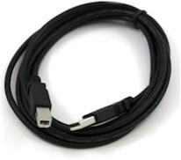
In case you use Arduino Nano, you will need an A to Mini-B cable instead as shown in the following image.
Step 2 − Download Arduino IDE Software.
You can get different versions of Arduino IDE from the Download page on the Arduino Official website. You must select your software, which is compatible with your operating system (Windows, IOS, or Linux). After your file download is complete, unzip the file.

Step 3 − Power up your board.
The Arduino Uno, Mega, Duemilanove and Arduino Nano automatically draw power from either, the USB connection to the computer or an external power supply. If you are using an Arduino Diecimila, you have to make sure that the board is configured to draw power from the USB connection. The power source is selected with a jumper, a small piece of plastic that fits onto two of the three pins between the USB and power jacks. Check that it is on the two pins closest to the USB port.
Connect the Arduino board to your computer using the USB cable. The green power LED (labeled PWR) should glow.
Step 4 − Launch Arduino IDE.
After your Arduino IDE software is downloaded, you need to unzip the folder. Inside the folder, you can find the application icon with an infinity label (application.exe). Double-click the icon to start the IDE.

Step 5 − Open your first project.
Once the software starts, you have two options −
- Create a new project.
- Open an existing project example.
To create a new project, select File → New.
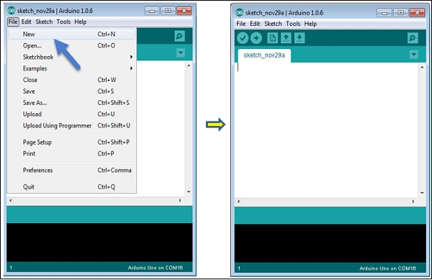
To open an existing project example, select File → Example → Basics → Blink.
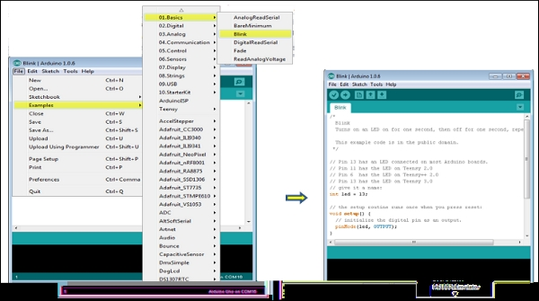
Here, we are selecting just one of the examples with the name Blink. It turns the LED on and off with some time delay. You can select any other example from the list.
Step 6 − Select your Arduino board.
To avoid any error while uploading your program to the board, you must select the correct Arduino board name, which matches with the board connected to your computer.
Go to Tools → Board and select your board.
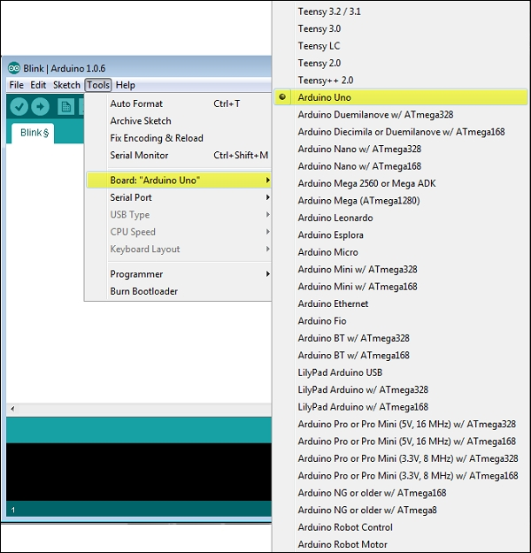
Here, we have selected Arduino Uno board according to our tutorial, but you must select the name matching the board that you are using.
Step 7 − Select your serial port.
Select the serial device of the Arduino board. Go to Tools → Serial Port menu. This is likely to be COM3 or higher (COM1 and COM2 are usually reserved for hardware serial ports). To find out, you can disconnect your Arduino board and re-open the menu, the entry that disappears should be of the Arduino board. Reconnect the board and select that serial port.
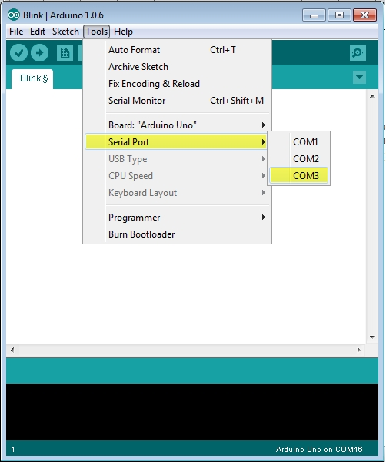
Step 8 − Upload the program to your board.
Before explaining how we can upload our program to the board, we must demonstrate the function of each symbol appearing in the Arduino IDE toolbar.
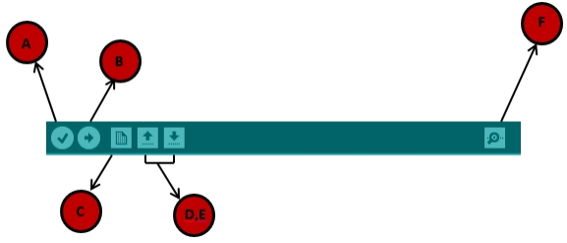
A − Used to check if there is any compilation error.
B − Used to upload a program to the Arduino board.
C − Shortcut used to create a new sketch.
D − Used to directly open one of the example sketch.
E − Used to save your sketch.
F − Serial monitor used to receive serial data from the board and send the serial data to the board.
Now, simply click the "Upload" button in the environment. Wait a few seconds; you will see the RX and TX LEDs on the board, flashing. If the upload is successful, the message "Done uploading" will appear in the status bar.
Note − If you have an Arduino Mini, NG, or other board, you need to press the reset button physically on the board, immediately before clicking the upload button on the Arduino Software.
CONNECTING A BATTERY
For stand-alone operation, the board is powered by a battery rather than through the USB connection to the computer. While the external power can be anywhere in the range of 6 to 24 V (for example, you could use a car battery), a standard 9 V battery is convenient. While you could jam the leads of a battery snap into the Vin and Gnd connections on the board, it is better to solder the battery snap leads to a DC power plug and connect to the power jack on the board. A suitable plug is part number 28760 from www.jameco.com. Here is what this looks like.
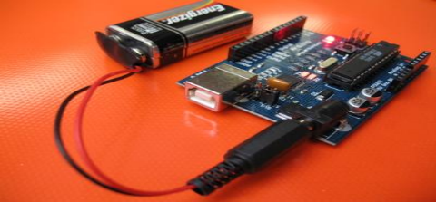
Fig: Arduino with battery
Disconnect your Arduino from the computer. Connect a 9 V battery to the Arduino power jack using the battery snap adapter. Confirm that the blinking program runs. This shows that you can power the Arduino from a battery and that the program you download runs without needing a connection to the host PC .
Moving On
Connect your Arduino to the computer with the USB cable. You do not need the battery for now. The green PWR LED will light. If there was already a program burned into the Arduino, it will run.
Start the Arduino development environment. In Arduino-speak, programs are called “sketches”, but here we will just call them programs.
In the editing window that comes up, enter the following program, paying attention to where semi-colons appear at the end of command lines.
void setup()
{
Serial.begin(9600);
Serial.println("Hello World");
}
void loop() {}
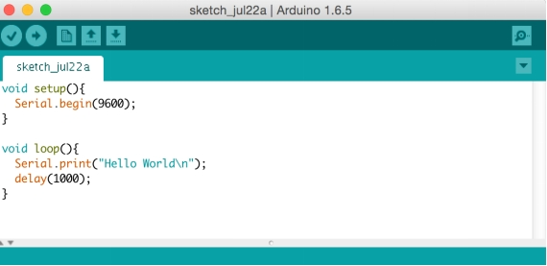
MC PROGRAMMING LANGUAGE: EMBEDDED C -

This is the most widely used programming language for embedded processors/controllers. Assembly is also used but mainly to implement those portions of the code where very high timing accuracy, code size efficiency, etc. are prime requirements. Embedded C is perhaps the most popular languages among Embedded Programmers for programming Embedded Systems. There are many popular programming languages like Assembly, BASIC, C++ etc. that are often used for developing Embedded Systems but Embedded C remains popular due to its efficiency, less development time and portability.

ULTRASONIC SENSOR(HC-SR04)
The HC-SR04 is a type of ultrasonic sensor which uses sonar to find out the distance of the object from the sensor. It provides an outstanding range of non-contact detection with high accuracy & stable readings. It includes t
wo modules like ultrasonic transmitter & receiver. This sensor is used in a variety of applications like measurement of direction and speed, burglar alarms, medical, sonar, humidifiers, wireless charging, non-destructive testing, and ultrasonography.
The HC-SR04 is a type of ultrasonic sensor which uses sonar to find out the distance of the object from the sensor. It provides an outstanding range of non-contact detection with high accuracy & stable readings. It includes two modules like ultrasonic transmitter & receiver. This sensor is used in a variety of applications like measurement of direction and speed, burglar alarms, medical, sonar, humidifiers, wireless charging, non-destructive testing, and ultrasonography.
HC-SR04 ULTRASONIC SENSOR PINOUT
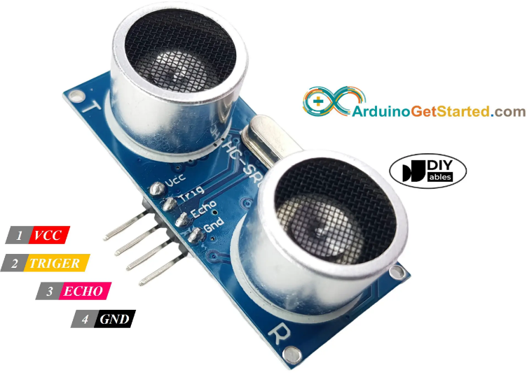

Pin Number | Pin Name | Description
1 | VCC | The VCC pin powers the sensor, typically with +5V
2 | Trigger | Trigger pin is an Input pin. This pin has to be kept high for 10us to initialize measurement by sending US wave.
3 | Echo | Echo pin is an Output pin. This pin goes high for a period of time which will be equal to the time taken for the US wave to return back to the sensor.
4 | Ground | This pin is connected to the Ground of the system.

HC-SR04 SENSOR FEATURES
- Operating voltage: +5V
- Theoretical Measuring Distance: 2cm to 450cm
- Practical Measuring Distance: 2cm to 80cm
- Accuracy: 3mm
- Measuring angle covered: <15°
- Operating Current: <15mA
- Operating Frequency: 40Hz
HC-SR04 ULTRASONIC SENSOR - WORKING
As shown above the HC-SR04 Ultrasonic (US) sensor is a 4 pin module, whose pin names are VCC, Trigger, Echo and Ground respectively. This sensor is a very popular sensor used in many applications where measuring distance or sensing objects are required. The module has two eyes like projects in the front which forms the Ultrasonic transmitter and Receiver. The sensor works with the simple high school formula that
Distance = Speed × Time
The Ultrasonic transmitter transmits an ultrasonic wave, this wave travels in air and when it gets objected by any material it gets reflected back toward the sensor this reflected wave is observed by the Ultrasonic receiver module as shown in the picture below
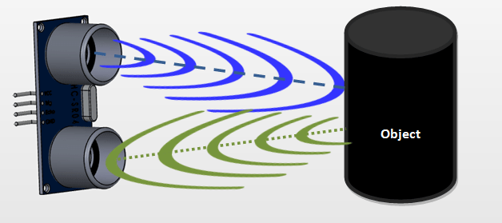

INTERFACING WITH ARDUINO UNO

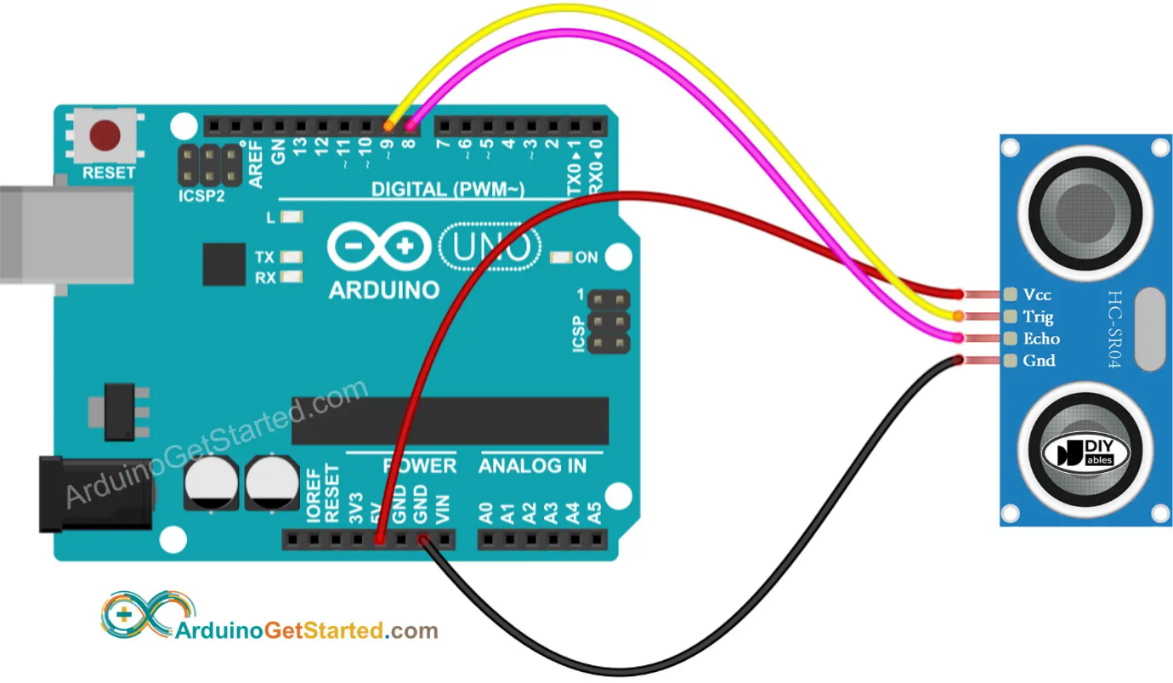

APPLICATIONS
- Used to avoid and detect obstacles with robots like biped robot, obstacle avoider robot, path finding robot etc.
- Used to measure the distance within a wide range of 2cm to 400cm
- Can be used to map the objects surrounding the sensor by rotating it
- Depth of certain places like wells, pits etc can be measured since the waves can penetrate through water
L293D MOTOR DRIVER

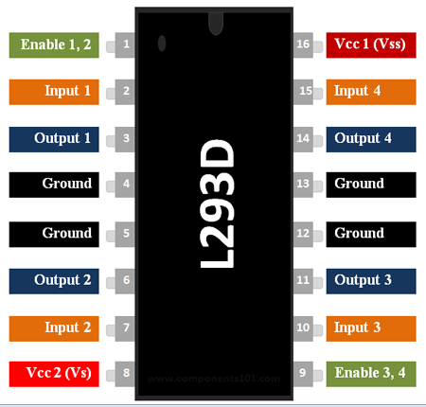
L293D Motor Driver IC

L293D Pin Configuration
Pin Number | Pin Name | Description
1 | Enable 1,2 | This pin enables the input pin Input 1(2) and Input 2(7)
2 | Input 1 | Directly controls the Output 1 pin. Controlled by digital circuits
3 | Output 1 | Connected to one end of Motor 1
4 | Ground | Ground pins are connected to ground of circuit (0V)
5 | Ground | Ground pins are connected to ground of circuit (0V)
6 | Output 2 | Connected to another end of Motor 1
7 | Input 2 | Directly controls the Output 2 pin. Controlled by digital circuits
8 | Vcc2 (Vs) | Connected to Voltage pin for running motors (4.5V to 36V)
9 | Enable 3,4 | This pin enables the input pin Input 3(10) and Input 4(15)
10 | Input 3 | Directly controls the Output 3 pin. Controlled by digital circuits
11 | Output 3 | Connected to one end of Motor 2
12 | Ground | Ground pins are connected to ground of circuit (0V)
13 | Ground | Ground pins are connected to ground of circuit (0V)
14 | Output 4 | Connected to another end of Motor 2
15 | Input 4 | Directly controls the Output 4 pin. Controlled by digital circuits
16 | Vcc2 (Vss) | Connected to +5V to enable IC function
Features
- Can be used to run Two DC motors with the same IC.
- Speed and Direction control is possible
- Motor voltage Vcc2 (Vs): 4.5V to 36V
- Maximum Peak motor current: 1.2A
- Maximum Continuous Motor Current: 600mA
- Supply Voltage to Vcc1(vss): 4.5V to 7V
- Transition time: 300ns (at 5Vand 24V)
- Automatic Thermal shutdown is available
- Available in 16-pin DIP, TSSOP, SOIC packages
Note: Complete Technical Details can be found in the L293D datasheet given at the end of this page.
L293D Equivalent Dual Timer IC
LB1909MC, SN754410, ULN2003
Where to use L293D IC
The L293D is a popular 16-Pin Motor Driver IC. As the name suggests it is mainly used to drive motors. A single L293D IC is capable of running two DC motors at the same time; also the direction of these two motors can be controlled independently. So if you have motors which has operating voltage less than 36V and operating current less than 600mA, which are to be controlled by digital circuits like Op-Amp, 555 timers, digital gates or even Microcontrollers like Arduino, PIC, ARM etc.. this IC will be the right choice for you.
How to use a L293D Motor Driver IC
Using this L293D motor driver IC is very simple. The IC works on the principle of Half H-Bridge, let us not go too deep into what H-Bridge means, but for now just know that H bridge is a set up which is used to run motors both in clock wise and anti clockwise direction. As said earlier this IC is capable of running two motors at the any direction at the same time, the circuit to achieve the same is shown below.
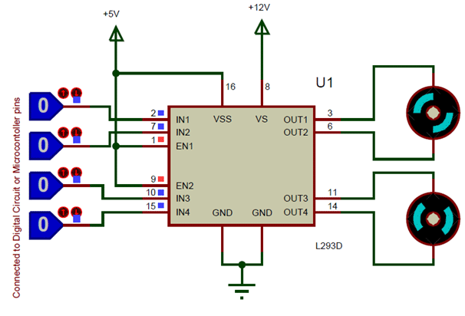
All the Ground pins should be grounded. There are two power pins for this IC, one is the Vss(Vcc1) which provides the voltage for the IC to work, this must be connected to +5V. The other is Vs(Vcc2) which provides voltage for the motors to run, based on the specification of your motor you can connect this pin to anywhere between 4.5V to 36V, here I have connected to +12V.
The Enable pins (Enable 1,2 and Enable 3,4) are used to Enable Input pins for Motor 1 and Motor 2 respectively. Since in most cases we will be using both the motors both the pins are held high by default by connecting to +5V supply. The input pins Input 1,2 are used to control the motor 1 and Input pins 3,4 are used to control the Motor 2. The input pins are connected to the any Digital circuit or microcontroller to control the speed and direction of the motor. You can toggle the input pins based on the following table to control your motor.
Input 1 = HIGH(5v) | Output 1 = HIGH | Motor 1 rotates in Clock wise Direction
Input 2 = LOW(0v) | Output 2 = LOW
Input 3 = HIGH(5v) | Output 1 = HIGH | Motor 2 rotates in Clock wise Direction
Input 4 = LOW(0v) | Output 2 = LOW

Input 1 = LOW(0v) | Output 1 = LOW | Motor 1 rotates in Anti-Clock wise Direction
Input 2 = HIGH(5v) | Output 2 = HIGH
Input 3 = LOW(0v) | Output 1 = LOW | Motor 2 rotates in Anti -Clock wise Direction
Input 4 = HIGH(5v) | Output 2 = HIGH

Input 1 = HIGH(5v) | Output 1 = HIGH | Motor 1 stays still
Input 2 = HIGH(5v) | Output 2 = HIGH
Input 3 = HIGH(5v) | Output 1 = LOW | Motor 2 stays still
Input 4 = HIGH(5v) | Output 2 = HIGH

Applications
- Used to drive high current Motors using Digital Circuits
- Can be used to drive Stepper motors
- High current LED’s can be driven
- Relay Driver module (Latching Relay is possible)

DC MOTOR:
A DC motor is an electrical machine that converts electrical energy into mechanical energy. In a DC motor, the input electrical energy is the direct current which is transformed into the mechanical rotation. In this session, let us know what is a DC motor, types of DC motor and their applications.

What is a DC Motor?
A DC motor is defined as a class of electrical motors that convert direct current electrical energy into mechanical energy.
From the above definition, we can conclude that any electric motor that is operated using direct current or DC is called a DC motor. We will understand the DC motor construction and how a DC motor converts the supplied DC electrical energy into mechanical energy in the next few sections.

DC Motor Diagram

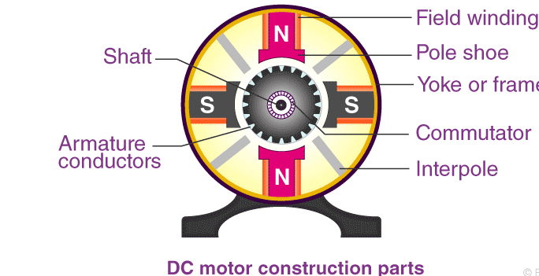

Different Parts of a DC Motor
A DC motor is composed of the following main parts::

Armature or Rotor
The armature of a DC motor is a cylinder of magnetic laminations that are insulated from one another. The armature is perpendicular to the axis of the cylinder. The armature is a rotating part that rotates on its axis and is separated from the field coil by an air gap.

Field Coil or Stator
A DC motor field coil is a non-moving part on which winding is wound to produce a magnetic field. This electro-magnet has a cylindrical cavity between its poles.

Commutator and Brushes
Commutator
The commutator of a DC motor is a cylindrical structure that is made of copper segments stacked together but insulated from each other using mica. The primary function of a commutator is to supply electrical current to the armature winding.
Brushes
The brushes of a DC motor are made with graphite and carbon structure. These brushes conduct electric current from the external circuit to the rotating commutator. Hence, we come to understand that the commutator and the brush unit are concerned with transmitting the power from the static electrical circuit to the mechanically rotating region or the rotor.

DC Motor Working
In the previous section, we discussed the various components of a DC motor. Now, using this knowledge let us understand the working of DC motors.
A magnetic field arises in the air gap when the field coil of the DC motor is energised. The created magnetic field is in the direction of the radii of the armature. The magnetic field enters the armature from the North pole side of the field coil and “exits” the armature from the field coil’s South pole side.
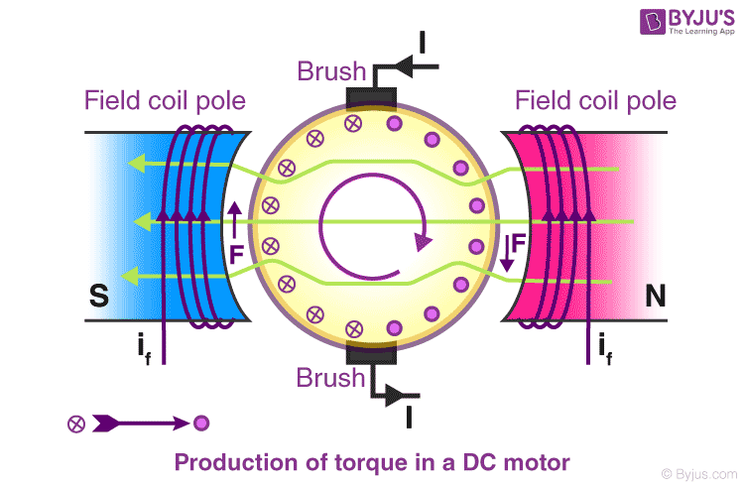
The conductors located on the other pole are subjected to a force of the same intensity but in the opposite direction. These two opposing forces create a torque that causes the motor armature to rotate.
Working principle of DC motor
When kept in a magnetic field, a current-carrying conductor gains torque and develops a tendency to move. In short, when electric fields and magnetic fields interact, a mechanical force arises. This is the principle on which the DC motors work.

Types of DC motor
DC motors have a wide range of applications ranging from electric shavers to automobiles. To cater to this wide range of applications, they are classified into different types based on the field winding connections to the armature as:
- Self Excited DC Motor
- Separately Excited DC Motor
Now, let us discuss the various types of DC Motors in detail.

Self Excited DC Motor
In self-excited DC motors, the field winding is connected either in series or parallel to the armature winding. Based on this, the self-excited DC motor can further be classified as:
- Shunt wound DC motor
- Series wound DC motor
- Compound wound DC motor

Shunt wound DC motor
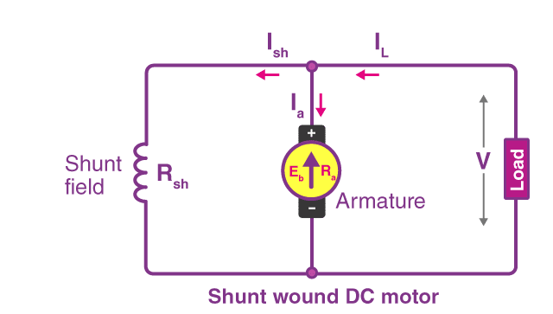
In a shunt wound motor, the field winding is connected parallel to the armature as shown in the figure.

Series wound DC motor
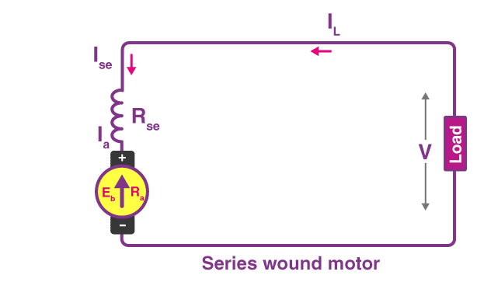
In a series wound DC motor, the field winding is connected in series with the armature winding as shown in the figure.

Compound wound DC motor
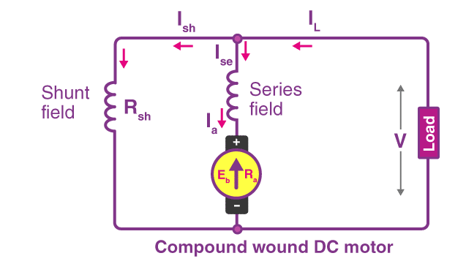
DC motors having both shunt and series field winding is known as Compound DC motor, as shown in the figure. The compound motor is further divided into:
- Cumulative Compound Motor
- Differential Compound Motor
In a cumulative compound motor, the magnetic flux produced by both the windings is in the same direction. In a differential compound motor, the flux produced by the series field windings is opposite to the flux produced by the shunt field winding.

Separately Excited DC Motor
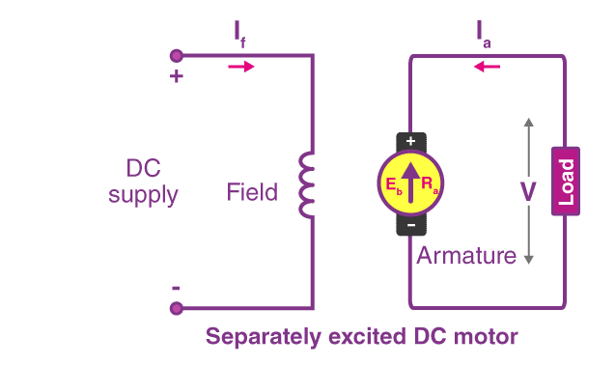
In a separately excited DC motor, the field coils are energised from an external source of DC supply as shown in the figure.

Brushed DC Motor vs Brushless DC Motor
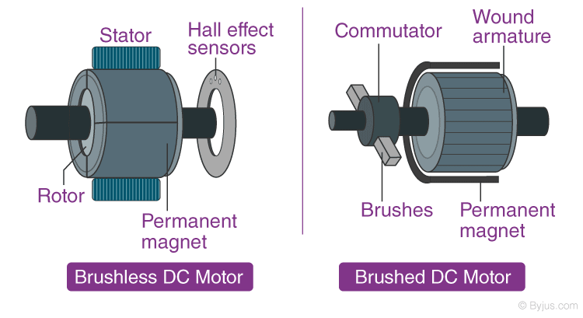
A brushless DC motor, also known as synchronous DC motor, unlike brushed DC motors, do not have a commutator. The commutator in a brushless DC motor is replaced by an electronic servomechanism that can detect and adjust the angle of the rotor.
A brushed DC motor features a commutator that reverses the current every half cycle and creates single direction torque. While brushed DC motors remain popular, many have been phased out for more efficient brushless models in recent years.

Applications of DC Motor
The applications of different types of DC motors are listed below:

Shunt DC Motors
Owing to the fairly constant speed and medium starting torque of shunt DC motors, they are used in the following applications:
- Centrifugal and reciprocating pumps
- Lathe machines
- Blowers and Fans
- Drilling machines
- Milling machines
- Machine tools
LED
Introduction:
A light-emitting diode (LED) is a semiconductor light source. LEDs are used as indicator lamps in many devices, and are increasingly used for lighting. Introduced as a practical electronic component in 1962, early LEDs emitted low-intensity red light, but modern versions are available across the visible, ultraviolet and infrared wavelengths, with very high brightness.
The LED is based on the semiconductor diode. When a diode is forward biased, electrons are able to recombine with holes within the device, releasing energy in the form of photons. This effect is called electroluminescence and the color of the light (corresponding to the energy of the photon) is determined by the energy gap of the semiconductor. An LED is usually small in area (less than 1 mm²), and integrated optical components are used to shape its radiation pattern and assist in reflection. LEDs present many advantages over incandescent light sources including lower energy consumption, longer lifetime, improved robustness, smaller size, faster switching, and greater durability and reliability. However, they are relatively expensive and require more precise current and heat management than traditional light sources. Current LED products for general lighting are more expensive to buy than fluorescent lamp sources of comparable output.
Working: Charge-carriers—electrons and holes—flow into the junction from electrodes with different voltages. When an electron meets a hole, it falls into a lower energy level, and releases energy in the form of a photon. The wavelength of the light emitted, and therefore its color, depends on the band gap energy of the materials forming the p-n junction. In silicon or germanium diodes, the electrons and holes recombine by a non-radiative transition which produces no optical emission, because these are indirect band gap materials. The materials used for the LED have a direct band gap with energies corresponding to near-infrared, visible or near-ultraviolet light.
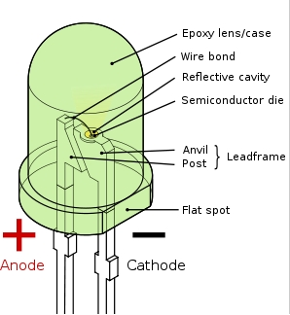

Colours and materials :
 | Color | Wavelength (nm) | Voltage (V) | Semiconductor Material
 | Infrared | λ > 760 | ΔV < 1.9 | Gallium arsenide (GaAs)  Aluminum gallium arsenide (AlGaAs)
 | Red | 610 < λ < 760 | 1.63 < ΔV < 2.03 | Aluminum gallium arsenide (AlGaAs)  Gallium arsenide phosphide (GaAsP)  Aluminium gallium indium phosphide (AlGaInP)  Gallium(III) phosphide (GaP)
 | Orange | 590 < λ < 610 | 2.03 < ΔV < 2.10 | Gallium arsenide phosphide (GaAsP)  Aluminum gallium indium phosphide (AlGaInP)  Gallium(III) phosphide (GaP)
 | Yellow | 570 < λ < 590 | 2.10 < ΔV < 2.18 | Gallium arsenide phosphide (GaAsP)  Aluminium gallium indium phosphide (AlGaInP)  Gallium(III) phosphide (GaP)
 | Green | 500 < λ < 570 | 1.9[42] < ΔV < 4.0 | Indium gallium nitride (InGaN) / Gallium(III) nitride (GaN)  Gallium(III) phosphide (GaP)  Aluminium gallium indium phosphide (AlGaInP)  Aluminium gallium phosphide (AlGaP)
 | Blue | 450 < λ < 500 | 2.48 < ΔV < 3.7 | Zinc selenide (ZnSe)  Indium gallium nitride (InGaN)  Silicon carbide (SiC) as substrate  Silicon (Si) as substrate — (under development)
 | Violet | 400 < λ < 450 | 2.76 < ΔV < 4.0 | Indium gallium nitride (InGaN)
 | Purple | multiple types | 2.48 < ΔV < 3.7 | Dual blue/red LEDs,  blue with red phosphor,  or white with purple plastic
 | Ultraviolet | λ < 400 | 3.1 < ΔV < 4.4 | Diamond (235 nm)  Boron nitride (215 nm)  Aluminium nitride (AlN) (210 nm)  Aluminium gallium nitride (AlGaN)  Aluminium gallium indium nitride (AlGaInN) — (down to 210 nm)
DHT11
Humidity is the measure of water vapour present in the air. The level of humidity in air affects various physical, chemical and biological processes. In industrial applications, humidity can affect the business cost of the products, health and safety of the employees. So, in semiconductor industries and control system industries measurement of humidity is very important. Humidity measurement determines the amount of moisture present in the gas that can be a mixture of water vapour, nitrogen, argon or pure gas etc… Humidity sensors are of two types based on their measurement units. They are a relative humidity sensor and Absolute humidity sensor. DHT11 is a digital temperature and humidity sensor.
What is a DHT11 Sensor?
DHT11 is a low-cost digital sensor for sensing temperature and humidity. This sensor can be easily interfaced with any micro-controller such as Arduino, Raspberry Pi etc… to measure humidity and temperature instantaneously.
DHT11 humidity and temperature sensor is available as a sensor and as a module. The difference between this sensor and module is the pull-up resistor and a power-on LED. DHT11 is a relative humidity sensor. To measure the surrounding air this sensor uses a thermistor and a capacitive humidity sensor.

Working Principle of DHT11 Sensor

DHT11 sensor consists of a capacitive humidity sensing element and a thermistor for sensing temperature. The humidity sensing capacitor has two electrodes with a moisture holding substrate as a dielectric between them. Change in the capacitance value occurs with the change in humidity levels. The IC measure, process this changed resistance values and change them into digital form.
For measuring temperature this sensor uses a Negative Temperature coefficient thermistor, which causes a decrease in its resistance value with increase in temperature. To get larger resistance value even for the smallest change in temperature, this sensor is usually made up of semiconductor ceramics or polymers.
The temperature range of DHT11 is from 0 to 50 degree Celsius with a 2-degree accuracy. Humidity range of this sensor is from 20 to 80% with 5% accuracy. The sampling rate of this sensor is 1Hz. i.e., it gives one reading for every second. DHT11 is small in size with operating voltage from 3 to 5 volts. The maximum current used while measuring is 2.5mA.
DHT11 PINOUT
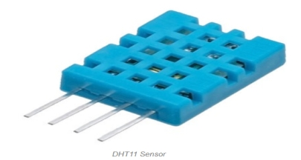
DHT11 sensor has four pins- VCC, GND, Data Pin and a not connected pin. A pull-up resistor of 5k to 10k ohms is provided for communication between sensor and micro-controller.
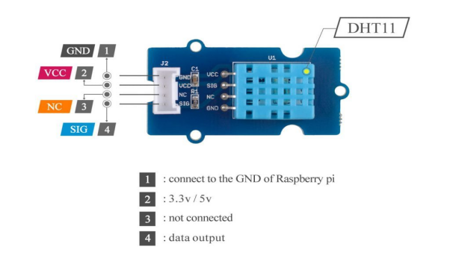 INTERFACING WITH ARDUINO

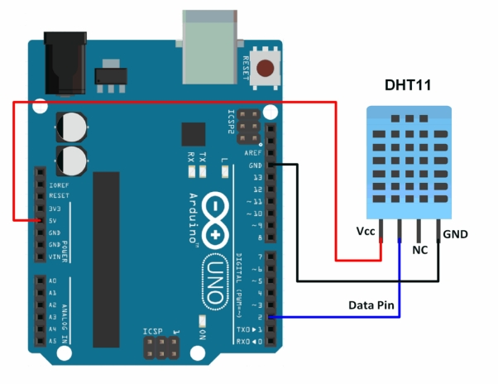
APPLICATIONS
This sensor is used in various applications such as measuring humidity and temperature values in heating, ventilation and air conditioning systems. Weather stations also use these sensors to predict weather conditions. The humidity sensor is used as a preventive measure in homes where people are affected by humidity. Offices, cars, museums, greenhouses and industries use this sensor for measuring humidity values and as a safety measure.
16 * 2 Alphanumeric LCD

Description

Liquid crystal display is very important device in embedded system. It offers high flexibility to user as he can display the required data on it. A liquid crystal display (LCD) is a thin, flat electronic visual display that uses the light modulating properties of liquid crystals (LCs). LCs do not emit light directly. LCDs therefore need a light source and are classified as "passive" displays. Here the lcd has different memories to display data, those are discussed below.

Block Diagram

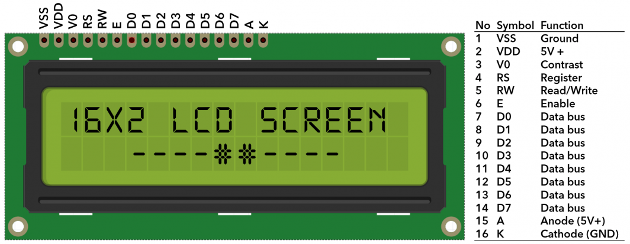

Display Data RAM
Display data RAM (DDRAM) stores display data represented in 8-bit character codes. Its extended capacity is 80 X 8 bits, or 80 characters. The area in display data RAM (DDRAM) that is not used for display can be used as general data RAM. So whatever you send on the DDRAM is actually displayed on the LCD. For LCDs like 1x16, only 16 characters are visible, so whatever you write after 16 chars is written in DDRAM but is not visible to the user.

Figure below will show you the DDRAM addresses of 2 Line LCD.
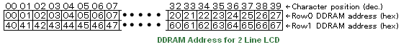
Character Generator ROM
Now you might be thinking that when you send an ascii value to DDRAM, how the character is displayed on LCD? so the answer is CGROM. The character generator ROM generates 5 x 8 dot or 5 x 10 dot character patterns from 8-bit character codes. It can generate 208 5 x 8 dot character patterns and 32 5 x 10 dot character patterns. User defined character patterns are also available by mask-programmed ROM.
BusyFlag
Busy Flag is an status indicator flag for LCD. When we send a command or data to the LCD for processing, this flag is set (i.e. BF =1) and as soon as the instruction is executed successfully this flag is cleared (BF = 0). This is helpful in producing and exact amount of delay for the LCDprocessing.
To read Busy Flag, the condition RS = 0 and R/W = 1 must be met and The MSB of the LCD data bus (D7) act as busy flag. When BF = 1 means LCD is busy and will not accept next command or data and BF = 0 means LCD is ready for the next command or data to process.

Instruction Register (IR) and Data Register(DR)
There are two 8-bit registers in HD44780 controller Instruction and Data register. Instruction register corresponds to the register where you send commands to LCD e.g LCD shift command, LCD clear, LCD address etc. and Data register is used for storing data which is to be displayed on LCD. When send the enable signal of the LCD is asserted, the data on the pins is latched in to the data register and data is then moved automatically to the DDRAM and hence is displayed on the LCD.
Data Register is not only used for sending data to DDRAM but also for CGRAM, the address where you want to send the data, is decided by the instruction you send to LCD.

16 x 2 Alphanumeric LCD Module Features
Intelligent, with built-in Hitachi HD44780 compatible LCD controller and RAM providing simple interfacing
- 61 x 15.8 mm viewing area
- 5 x 7 dot matrix format for 2.96 x 5.56 mm characters, plus cursor line
- Can display 224 different symbols
- Low power consumption (1 mA typical)
- Powerful command set and user-produced characters
- TTL and CMOS compatible
- Connector for standard 0.1-pitch pin headers
Schematic
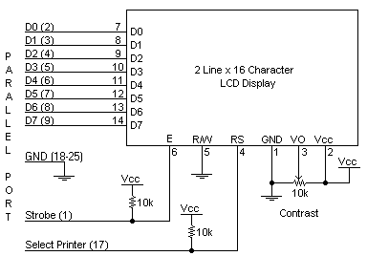
Specifications
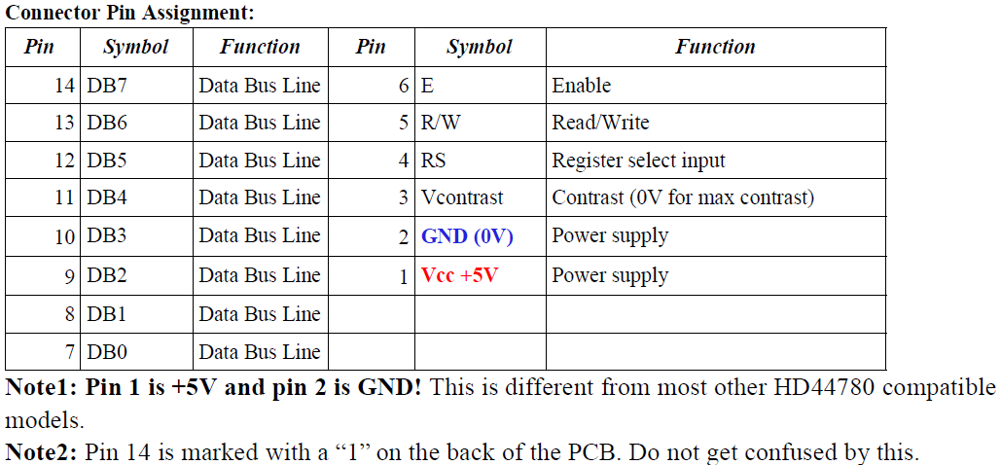
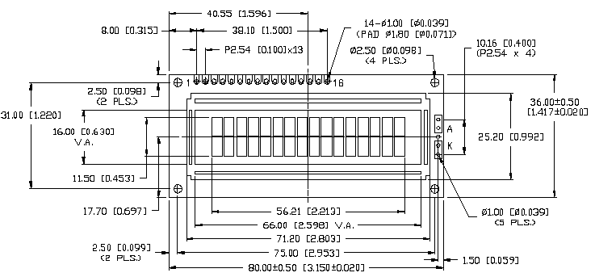
Circuit Description
Above is the quite simple schematic. The LCD panel's Enable and Register Select is connected to the Control Port. The Control Port is an open collector / open drain output. While most Parallel Ports have internal pull-up resistors, there are a few which don't. Therefore, by incorporating the two 10K external pull up resistors, the circuit is more portable for a wider range of computers, some of which may have no internal pull up resistors.
We make no effort to place the Data bus into reverse direction. Therefore, we hard wire the R/W line of the LCD panel, into write mode. This will cause no bus conflicts on the data lines. As a result, we cannot read back the LCD's internal Busy Flag which tells us if the LCD has accepted and finished processing the last instruction. This problem is overcome by inserting known delays into our program.
The 10k Potentiometer controls the contrast of the LCD panel. You can use a bench power supply set to 5v or use a onboard +5 regulator. Remember a few de-coupling capacitors, especially if you have trouble with the circuit working properly. The 2-line x 16-character LCD modules are available from a wide range of manufacturers and should all be compatible with the HD44780.

APPLICATIONS
Liquid Crystal Displays (LCDs) are widely used in various applications due to their energy efficiency, slim form factor, and ability to display high-quality images and text. Here are some of the common and diverse applications of LCD technology:
1. Television Screens.
2. Computer Monitors.
3. Laptops and Notebooks.
4. Smartphones and Tablets.
5. Digital Cameras
6. Medical Equipment.

IR Sensor
IR sensor is an electronic device, that emits the light in order to sense some object of the surroundings. An IR sensor can measure the heat of an object as well as detects the motion. Usually, in the infrared spectrum, all the objects radiate some form of thermal radiation. These types of radiations are invisible to our eyes, but infrared sensor can detect these radiations.
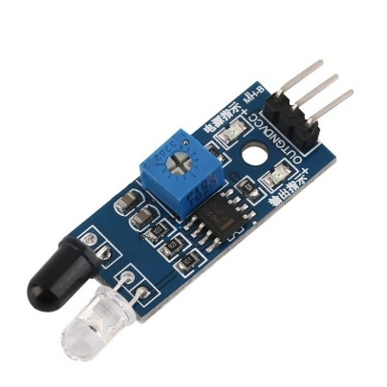
The emitter is simply an IR LED (Light Emitting Diode) and the detector is simply an IR photodiode . Photodiode is sensitive to IR light of the same wavelength which is emitted by the IR LED. When IR light falls on the photodiode, the resistances and the output voltages will change in proportion to the magnitude of the IR light received.
There are five basic elements used in a typical infrared detection system: an infrared source, a transmission medium, optical component, infrared detectors or receivers and signal processing. Infrared lasers and Infrared LED’s of specific wavelength used as infrared sources.
The three main types of media used for infrared transmission are vacuum, atmosphere and optical fibers. Optical components are used to focus the infrared radiation or to limit the spectral response.

Types of IR Sensor
There are two types of IR sensors are available and they are,
- Active Infrared Sensor
- Passive Infrared Sensor

Active Infrared Sensor
Active infrared sensors consist of two elements: infrared source and infrared detector. Infrared sources include the LED or infrared laser diode. Infrared detectors include photodiodes or phototransistors. The energy emitted by the infrared source is reflected by an object and falls on the infrared detector.

Passive Infrared Sensor
Passive infrared sensors are basically Infrared detectors. Passive infrared sensors do not use any infrared source and detector. They are of two types: quantum and thermal. Thermal infrared sensors use infrared energy as the source of heat. Thermocouples, pyroelectric detectors and bolometers are the common types of thermal infrared detectors. Quantum type infrared sensors offer higher detection performance. It is faster than thermal type infrared detectors. The photo sensitivity of quantum type detectors is wavelength dependent.

IR Sensor Working Principle
There are different types of infrared transmitters depending on their wavelengths, output power and response time. An IR sensor consists of an IR LED and an IR Photodiode, together they are called as PhotoCoupler or OptoCoupler.
IR Transmitter or IR LED
Infrared Transmitter is a light emitting diode (LED) which emits infrared radiations called as IR LED’s. Even though an IR LED looks like a normal LED, the radiation emitted by it is invisible to the human eye.
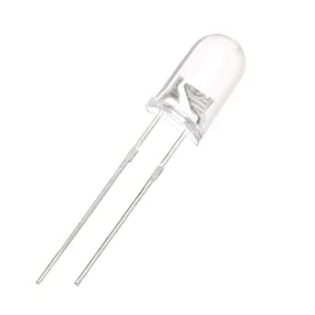
The picture of an Infrared LED is shown below.
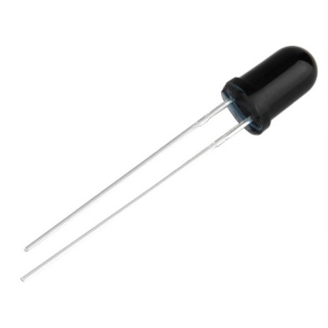
IR Receiver or Photodiode
Infrared receivers or infrared sensors detect the radiation from an IR transmitter. IR receivers come in the form of photodiodes and phototransistors. Infrared Photodiodes are different from normal photo diodes as they detect only infrared radiation. Below image shows the picture of an IR receiver or a photodiode,
Different types of IR receivers exist based on the wavelength, voltage, package, etc. When used in an infrared transmitter – receiver combination, the wavelength of the receiver should match with that of the transmitter.
The emitter is an IR LED and the detector is an IR photodiode. The IR photodiode is sensitive to the IR light emitted by an IR LED. The photo-diode’s resistance and output voltage change in proportion to the IR light received. This is the underlying working principle of the IR sensor.
When the IR transmitter emits radiation, it reaches the object and some of the radiation reflects back to the IR receiver. Based on the intensity of the reception by the IR receiver, the output of the sensor defines.

