CIVIL ENGINEERING Training Program:
We have offered training to CSE students through three modes:
- OJT-On job Training[Paid Internships]
- In hands Training[Class room training
- Online Training
In hands Training [Class room training & Online Training
Candidates who were not interested in paid internships or were rejected have undergone in-hands training at our Koti location. Our experienced trainers and branch in-charges have provided training in the following programs:
- AUTOCAD [30 days program]
- REVIT [30 days program]
- Sketch ups [20 days program]
- Advanced Surveying[25 days program]
- Quantity Surveying [20 days program]
Training Photos:
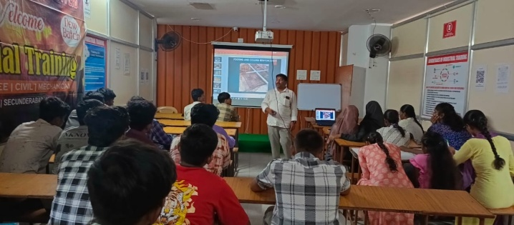 | 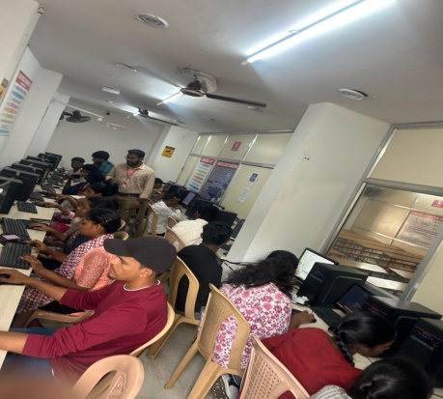
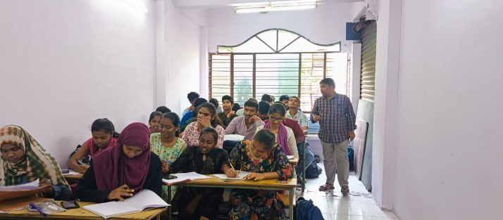 | 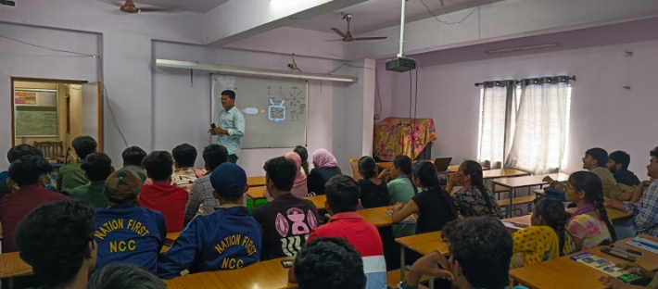
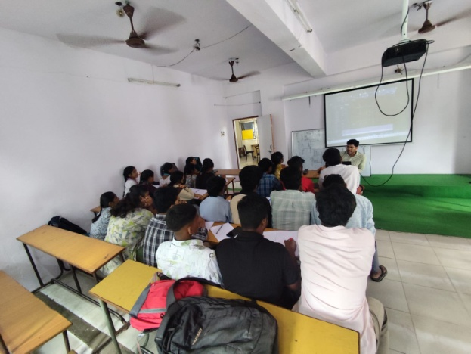 | 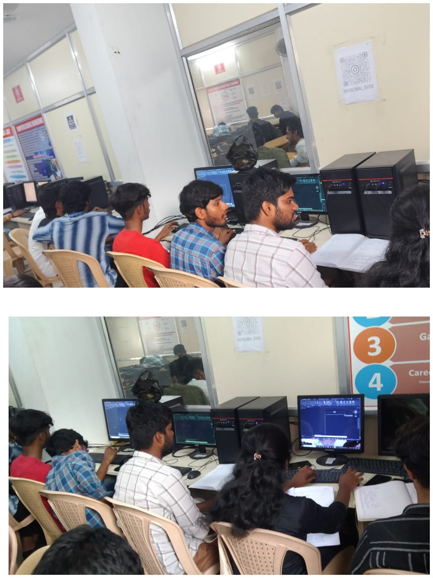

Industrial Visits
We have organized industrial visits (2 visits) to provide practical knowledge to candidates.
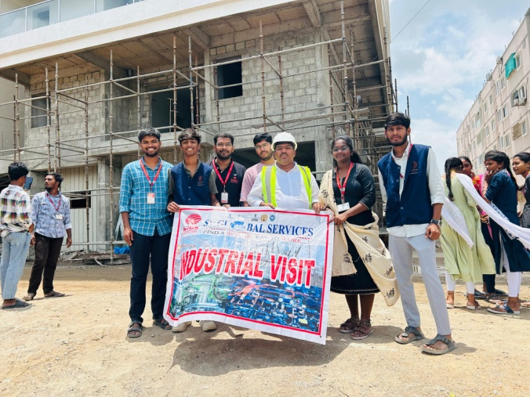 | 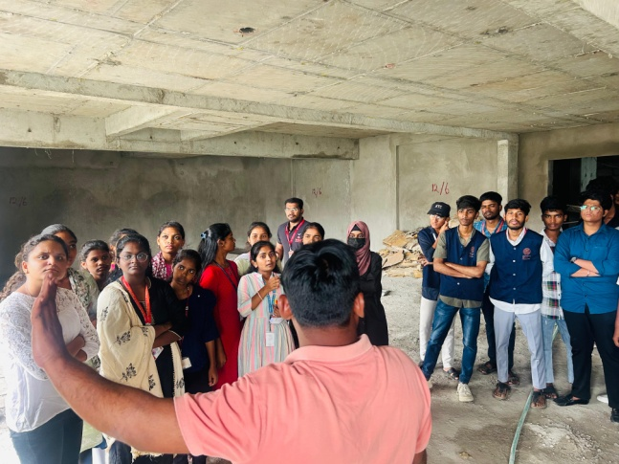
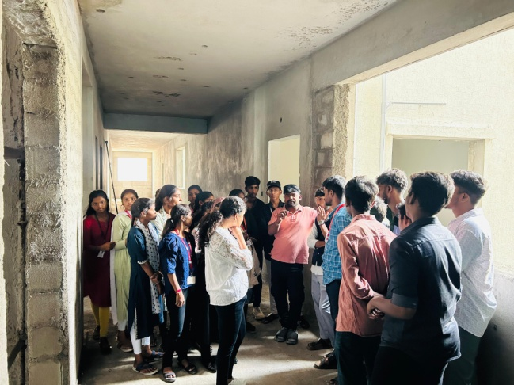 | 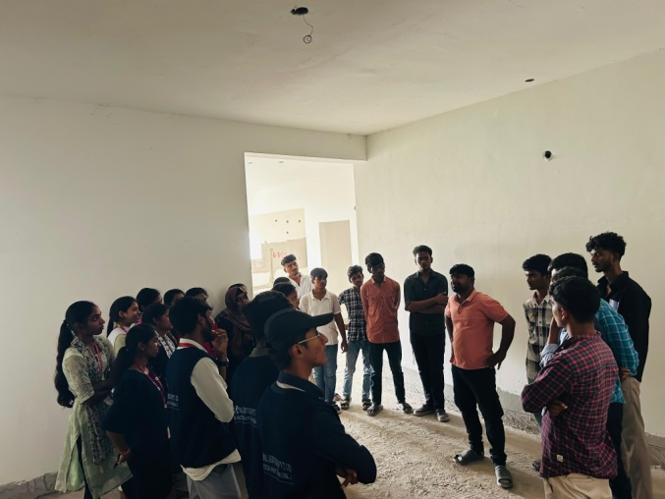

Work shops and CRT classes for basic communication:
Additionally, we have conducted workshops by Invent Artificial (USA-based Company) and Google training workshop in AI.
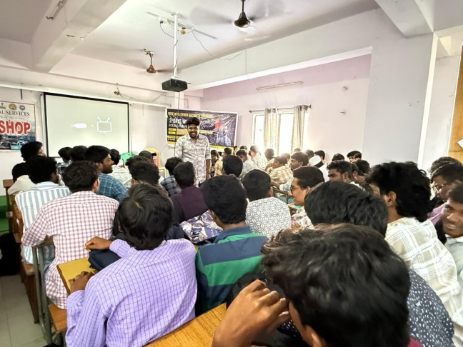 | 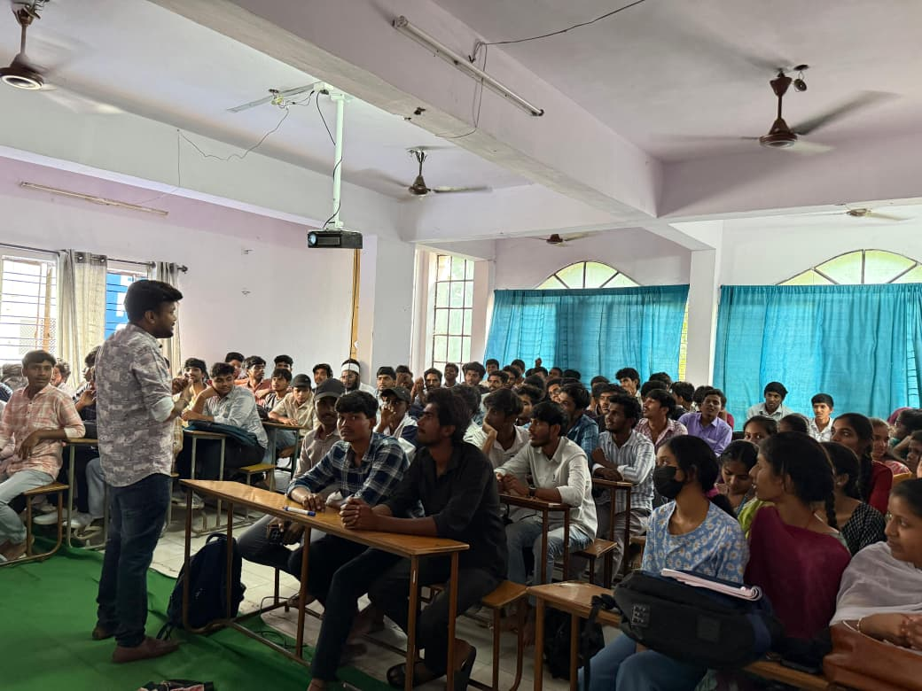
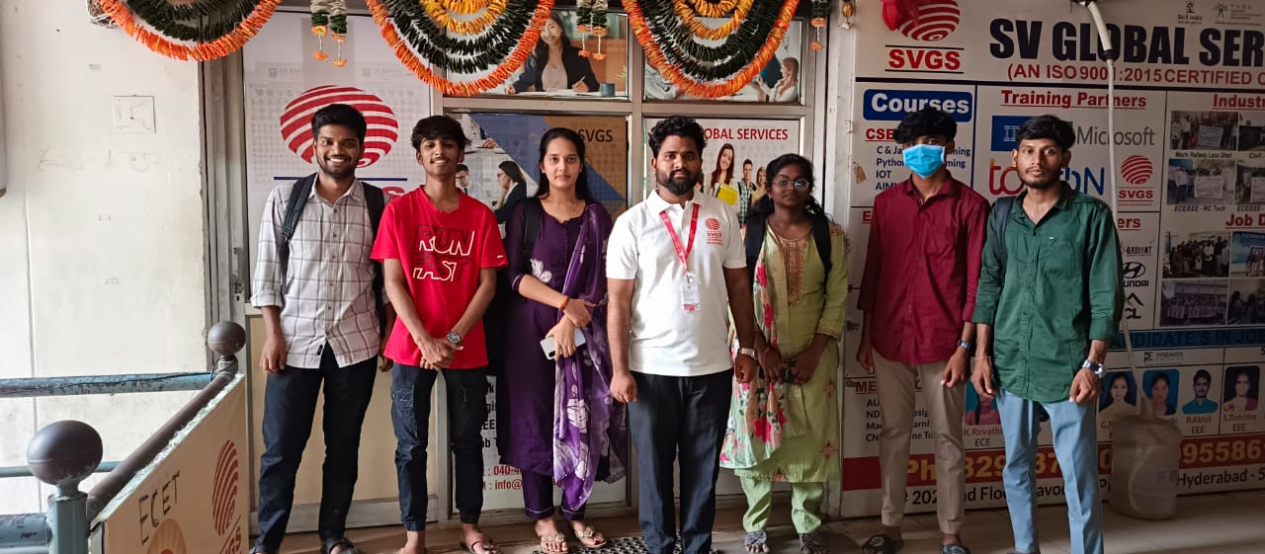 | 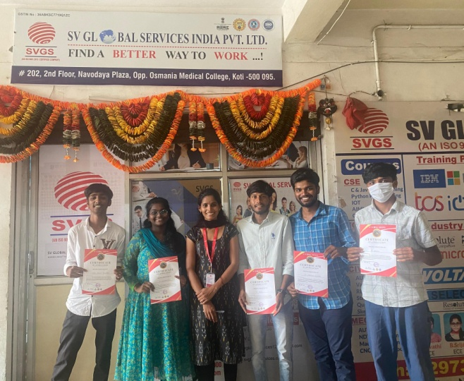

CSR and Skill Projects:
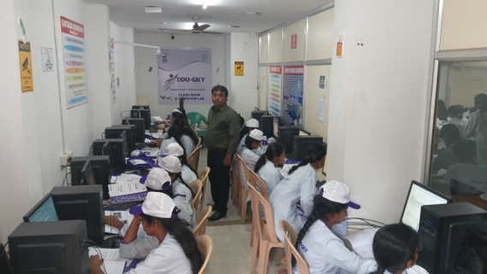 | 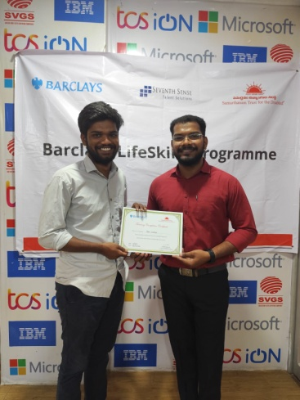
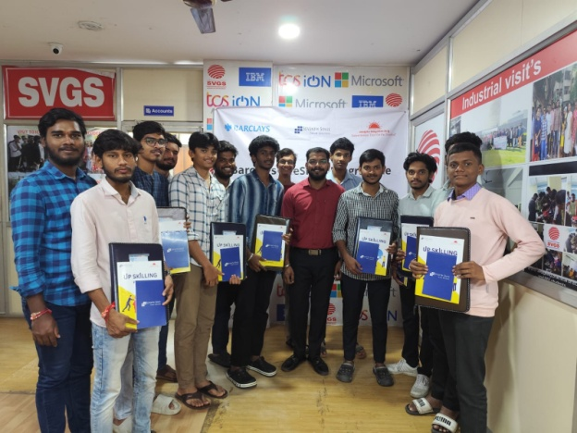 | 