CHAPTER 1-EMBEDDED SYSTEMS

INTRODUCTION

An embedded system is a combination of computer hardware and software designed for a specific function or functions within a larger system. The systems can be programmable or with fixed functionality. Industrial machines, consumer electronics, agricultural and process industry devices, automobiles, medical equipment, cameras, household appliances, airplanes, vending machines and toys, as well as mobile devices, are possible locations for an embedded system.

CHARACTERISTICS OF EMBEDDED SYSTEMS

The main characteristic of embedded systems is that they are task specific. They perform a single task within a larger system. For example, a mobile phone is not an embedded system, it is a combination of embedded systems that together allow it to perform a variety of general-purpose tasks. The embedded systems within it perform specialized functions. For example, the GUI performs the singular function of allowing the user to interface with the device. In short, they are programmable computers, but designed for specific purposes, not general ones.

ADDITIONALLY, EMBEDDED SYSTEMS CAN INCLUDE THE FOLLOWING CHARACTERISTICS:

comprised of hardware, software and firmware;

embedded in a larger system to perform a specific function as they are built for specialized tasks within the system, not various tasks;
either microprocessor-based or microcontroller-based -- both are integrated circuits that give the system compute power;

often used for sensing and real-time computing in internet of things (IoT) devices -- devices that are internet connected and do not require a user to operate;
vary in complexity and in function, which affects the type of software, firmware and hardware they use; and
often required to perform their function under a time constraint to keep the larger system functioning properly.
EMBEDDED SYSTEMS VARY IN COMPLEXITY, BUT GENERALLY CONSIST OF THREE MAIN ELEMENTS:

Hardware. The hardware of embedded systems is based around microprocessors and microcontroller. Microprocessors are very similar to microcontrollers, and generally refer to a CPU that is integrated with other basic computing components such as memory chips and digital signal processors . Microcontrollers have those components built into one chip.
Software. Software for embedded systems can vary in complexity. However, industrial-grade microcontrollers and embedded IoT systems generally run very simple software that requires little memory.
BASIC BLOCK DIAGRAM OF EMBEDDED SYSTEM:
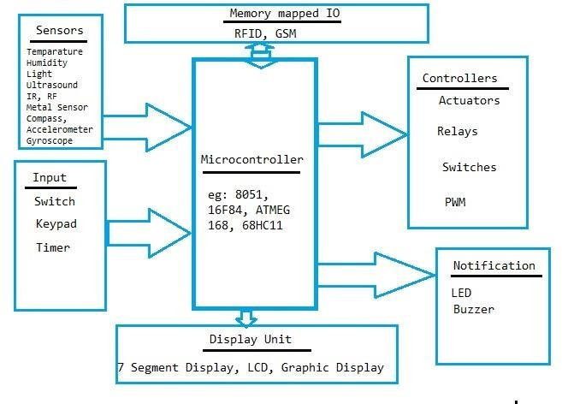
Fig 1.0: Block Diagram Of Embedded System

APPLICATIONS OF EMBEDDED SYSTEMS

Embedded systems are used in a variety of technologies across industries. Some examples include:
Automobiles. Modern cars commonly consist of many computers (sometimes as many as 100), or embedded systems, designed to perform different tasks within the vehicle. Some of these systems perform basic utility function and others provide entertainment or user-facing functions. Some embedded systems in consumer vehicles include cruise control, backup sensors, suspension control, navigation systems and airbag systems.
Mobile phones. These consist of many embedded systems, including GUI software and hardware, operating systems, cameras, microphones and USB I/O modules.
Industrial machines. They can contain embedded systems, like sensors, and can be embedded systems themselves. Industrial machines often have embedded automation systems that perform specific monitoring and control functions.
Medical equipment. These may contain embedded systems like sensors and control mechanisms. Medical equipment, such as industrial machines, also must be very user-friendly, so that human health isn't jeopardized by preventable machine mistakes. This means they'll often include a more complex OS and GUI designed for an appropriate UI.

ADVANTAGES OF EMBEDDED SYSTEMS

- The embedded system is easy for mass production.
- The embedded system is highly reliable.
- It has very few interconnections.
- The embedded system is small in size.
- The embedded system has less expensive.
- It has fast operation.
- It has improved product quality.
- It optimizes use of system resources.
- It has low power operation.

DISADVANTAGES OF EMBEDDED SYSTEMS

- The embedded systems are hard for maintenance as it is use and throw device.
- It has no technological improvement.
- Less power supply durability if it is battery operated.
- It has hard to take backup of embedded files

CHAPTER-2. MICROCONTROLLERS

MICROPROCESSORS AND MICROCONTROLLERS

Microprocessor | Microcontroller
Microprocessor contains ALU, General purpose registers, stack pointer, program counter, clock timing circuit, interrupt circuit | Microcontroller contains the circuitry of microprocessor, and in addition it has built in ROM, RAM, I/O Devices, Timers/Counters  etc.
It has many instructions to move data  between memory and CPU | It has few instructions to move data  between memory and CPU
Few bit handling instruction | It has many bit handling instructions
Less number of pins are  multifunctional | More number of pins are  multifunctional
Single memory map for data and  code (program) | Separate memory map for data and  code (program)
Access time for memory and IO are  more | Less access time for built in memory  and IO.
Microprocessor based system  requires additional hardware | It requires less additional hardwares
More flexible in the design point of view | Less flexible since the additional circuits which is residing inside the microcontroller is fixed for a particular  microcontroller
Large number of instructions with  flexible addressing modes | Limited number of instructions with  few addressing modes

RISC AND CISC CPU ARCHITECTURES
Microcontrollers with small instruction set are called reduced instruction set computer (RISC) machines and those with complex instruction set are called complex instruction set computer (CISC). Intel 8051 is an example of CISC machine whereas microchip PIC 18F87X is an example of RISC machine.

RISC | CISC
Only load/store instructions are used to access memory | In additions to load and store  instructions, memory access is possible with other instructions also.
Instructions executed by hardware | Instructions executed by the micro program
Fixed format instruction | Variable format instructions
Few addressing modes | Many addressing modes
Few instructions | Complex instruction set
Most of the have multiple register banks | Single register bank
Highly pipelined | Less pipelined
Complexity is in the compiler | Complexity in the microprogram

HARVARD & VON- NEUMANN CPU ARCHITECTURE

Von-Neumann (Princeton architecture) | Harvard architecture
It uses single memory space for both instructions and data. | It has separate program memory and data memory
It is not possible to fetch instruction code and data | Instruction code and data can be fetched simultaneously
Execution of instruction takes more machine cycle | Execution of instruction takes less machine cycle
Uses CISC architecture | Uses RISC architecture
Instruction pre-fetching is a main feature | Instruction parallelism is a main feature
Also known as control flow or control driven computers | Also known as data flow or data driven computers

Simplifies the chip design because of single memory space | Chip design is complex due to separate memory space
Eg. 8085, 8086, MC6800 | Eg. General purpose microcontrollers, special DSP chips  etc.

COMPUTER SOFTWARE
A set of instructions written in a specific sequence for the computer to solve a specific task is called a program and software is a collection of such programs.
The program stored in the computer memory in the form of binary numbers is called machine instructions. The machine language program is called object code.
An assembly language is a mnemonic representation of machine language. Machine language and assembly language are low level languages and are processor specific.
The assembly language program the programmer enters is called source code. The source code (assembly language) is translated to object code (machine language) using assembler.
Programs can be written in high level languages such as C, C++ etc. High level language will be converted to machine language using compiler or interpreter. Compiler reads the entire program and translate into the object code and then it is executed by the processor. Interpreter takes one statement of the high level language as input and translate it into object code and then executes.
THE 8051 ARCHITECTURE

Introduction

Salient features of 8051 microcontroller are given below.
- Eight bit CPU
- On chip clock oscillator
- 4Kbytes of internal program memory (code memory) [ROM]
- 128 bytes of internal data memory [RAM]
- 64 Kbytes of external program memory address space.
- 64 Kbytes of external data memory address space.
- 32 bi directional I/O lines (can be used as four 8 bit ports or 32 individually addressable I/O lines)

- Two 16 Bit Timer/Counter :T0, T1
- Full Duplex serial data receiver/transmitter  Four Register banks with 8 registers in each bank.
- Sixteen bit Program counter (PC) and a data pointer (DPTR)
- 8 Bit Program Status Word (PSW)
- 8 Bit Stack Pointer
- Five vector interrupt structure (RESET not considered as an interrupt.)
- 8051 CPU consists of 8 bit ALU with associated registers like accumulator ‘A’ , B register, PSW, SP, 16 bit program counter, stack pointer.
- ALU can perform arithmetic and logic functions on 8 bit variables.
- 8051 has 128 bytes of internal RAM which is divided into o Working registers [00 – 1F] o Bit addressable memory area [20 – 2F] o General purpose memory area (Scratch pad memory) [30-7F]
The 8051 architecture.
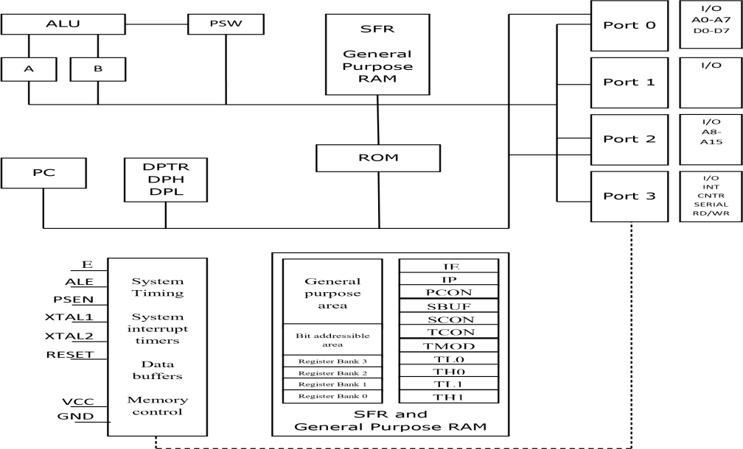
Fig 2.0: 8051 Architure

8051 has 4 K Bytes of internal ROM. The address space is from 0000 to 0FFFh. If the program size is more than 4 K Bytes 8051 will fetch the code automatically from external memory.
Accumulator is an 8 bit register widely used for all arithmetic and logical operations. Accumulator is also used to transfer data between external memory. B register is used along with Accumulator for multiplication and division. A and B registers together is also called MATH registers.
PSW (Program Status Word). This is an 8 bit register which contains the arithmetic status of ALU and the bank select bits of register banks.
CY - carry flag
AC - auxiliary carry flag

F0 - available to the user for general purpose RS1,RS0 - register bank select bits
OV - overflow
P - parity
Stack Pointer (SP) – it contains the address of the data item on the top of the stack. Stack may reside anywhere on the internal RAM. On reset, SP is initialized to 07 so that the default stack will start from address 08 onwards.
Data Pointer (DPTR) – DPH (Data pointer higher byte), DPL (Data pointer lower byte). This is a 16 bit register which is used to furnish address information for internal and external program memory and for external data memory.
Program Counter (PC) – 16 bit PC contains the address of next instruction to be executed. On reset PC will set to 0000. After fetching every instruction PC will increment by one.

PIN DIAGRAM
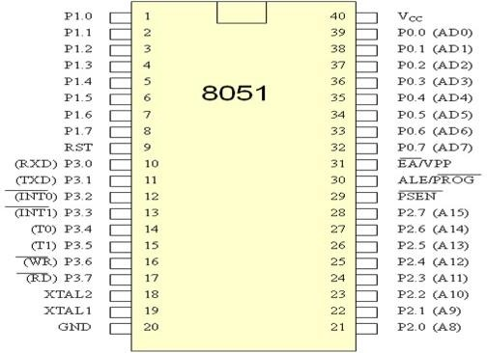

PINOUT DESCRIPTION

Pins 1-  8 | PORT 1. Each of these pins can be configured as  an input or an output.
Pin 9 | RESET. A logic one on this pin disables the microcontroller and clears the contents of most registers. In other words, the positive voltage on this pin resets the microcontroller. By applying logic zero to this pin, the  program starts execution from the beginning.
Pins10- 17 | PORT 3. Similar to port 1, each of these pins can  serve as general input or output. Besides, all of them have alternative functions

Pin 10 | RXD. Serial asynchronous communication input or  Serial synchronous communication output.
Pin 11 | TXD. Serial asynchronous communication output or Serial synchronous  communication clock output.
Pin 12 | INT0.External Interrupt 0 input
Pin 13 | INT1. External Interrupt 1 input
Pin 14 | T0. Counter 0 clock input
Pin 15 | T1. Counter 1 clock input
Pin 16 | WR. Write to external (additional) RAM
Pin 17 | RD. Read from external RAM
Pin 18,  19 | XTAL2, XTAL1. Internal oscillator input and output. A quartz crystal which specifies operating  frequency is usually connected to these pins.
Pin 20 | GND. Ground.
Pin 21-  28 | Port 2. If there is no intention to use external memory then these port pins are configured as general inputs/outputs. In case external memory is used, the higher address byte, i.e. addresses A8-A15 will appear on this port. Even though memory with capacity of 64Kb is not used, which means that not all eight port bits are used for its addressing, the rest of them are not available as  inputs/outputs.
Pin 29 | PSEN. If external ROM is used for storing program then a logic zero (0) appears on it every time the  microcontroller reads a byte from memory.
Pin 30 | ALE. Prior to reading from external memory, the microcontroller puts the lower address byte (A0-A7) on P0 and activates the ALE output. After receiving signal from the ALE pin, the external latch latches the state of  P0 and uses it as a memory chip address. Immediately

 | after that, the ALE pin is returned its previous logic state and P0 is now used as a Data Bus.
Pin 31 | EA. By applying logic zero to this pin, P2 and P3 are used for data and address transmission with no regard to whether there is internal memory or not. It means that even there is a program written to the microcontroller, it will not be executed. Instead, the program written to external ROM will be executed. By applying logic one to the EA pin, the microcontroller will use both memories,  first internal then external (if exists).
Pin 32-  39 | PORT 0. Similar to P2, if external memory is not used, these pins can be used as general inputs/outputs. Otherwise, P0 is configured as address output (A0-A7) when the ALE pin is driven high (1) or as data output  (Data Bus) when the ALE pin is driven low (0).
Pin 40 | VCC. +5V power supply.

MEMORY ORGANIZATION
Register Banks: 00h to 1Fh. The 8051 uses 8 general-purpose registers R0 through R7 (R0, R1, R2, R3, R4, R5, R6, and R7). There are four such register banks. Selection of register bank can be done through RS1,RS0 bits of PSW. On reset, the default Register Bank 0 will be selected.
Bit Addressable RAM: 20h to 2Fh. The 8051 supports a special feature which allows access to bit variables. This is where individual memory bits in Internal RAM can be set or cleared. In all there are 128 bits numbered 00h to 7Fh. Being bit variables any one variable can have a value 0 or 1. A bit variable can be set with a command such as SETB and cleared with a command such as CLR.
Example instructions are:
SETB 25h; sets the bit 25h (becomes 1) CLR 25h; clears bit 25h (becomes 0)
Note, bit 25h is actually bit 5 of Internal RAM location 24h.
The Bit Addressable area of the RAM is just 16 bytes of Internal RAM located between 20h and 2Fh.

General Purpose RAM: 30h to 7Fh. Even if 80 bytes of Internal RAM memory are available for general- purpose data storage, user should take care while using the memory location from 00 -2Fh since these locations are also the default register space, stack space, and bit addressable space. It is a good practice to use general purpose memory from 30 – 7Fh. The general purpose RAM can be accessed using direct or indirect addressing modes.

STACK
A stack is a last in first out memory. In 8051 internal RAM space can be used as stack. The address of the stack is contained in a register called stack pointer. Instructions PUSH and POP are used for stack operations.

CHAPTER-3. INSTRUCTION SYNTAX

General syntax for 8051 assembly language is as follows.

LABEL: OPCODE OPERAND; COMMENT

LABEL: (THIS IS NOT NECESSARY UNLESS THAT SPECIFIC LINE HAS TO BE ADDRESSED).
The label is a symbolic address for the instruction. When the program is assembled, the label will be given specific address in which that instruction is stored. Unless that specific line of instruction is needed by a branching instruction in the program, it is not necessary to label that line.
OPCODE: Opcode is the symbolic representation of the operation. The assembler converts the opcode to a unique binary code (machine language).
OPERAND: While opcode specifies what operation to perform, operand specifies where to perform that action. The operand field generally contains the source and destination of the data. In some cases only source or destination will be available instead of both. The operand will be either address of the data, or data itself. COMMENT: Always comment will begin with ; or // symbol. To improve the program quality, programmer may always use comments in the program.

ADDRESSING MODES

Various methods of accessing the data are called addressing modes. 8051 addressing modes are classified as follows.
- Immediate addressing.
- Register addressing.
- Direct addressing.
- Indirect addressing.
- Relative addressing.
- Absolute addressing.
- Long addressing.
- Indexed addressing.
- Bit inherent addressing.
- Bit direct addressing.
- Immediate addressing.

In this addressing mode the data is provided as a part of instruction itself. In other words data immediately follows the instruction.
Eg. MOV A,#30H
ADD A, #83 # Symbol indicates the data is immediate.

Register addressing.
In this addressing mode the register will hold the data. One of the eight general registers (R0 to R7) can be used and specified as the operand.
Eg. MOV A,R0 ADD A,R6
R0 – R7 will be selected from the current selection of register bank. The default register bank will be bank 0.
Direct addressing
There are two ways to access the internal memory. Using direct address and indirect address. Using direct addressing mode we can not only address the internal memory but SFRs also. In direct addressing, an 8 bit internal data memory address is specified as part of the instruction and hence, it can specify the address only in the range of 00H to FFH. In this addressing mode, data is obtained directly from the memory.
Eg. MOV A,60h ADD A,30h
Indirect addressing
The indirect addressing mode uses a register to hold the actual address that will be used in data movement. Registers R0 and R1 and DPTR are the only registers that can be used as data pointers. Indirect addressing cannot be used to refer to SFR registers. Both R0 and R1 can hold 8 bit address and DPTR can hold 16 bit address.
Eg. MOV A,@R0
ADD A,@R1 MOVX A,@DPTR
Indexed addressing.
In indexed addressing, either the program counter (PC), or the data pointer (DTPR)—is used to hold the base address, and the A is used to hold the offset address. Adding the value of the base address to the value of the offset address forms the effective address. Indexed addressing is used with JMP or MOVC instructions.
Look up tables are easily implemented with the help of index addressing.
MOVC A, @A+DPTR // copies the contents of memory location pointed by the sum of the accumulator A and the DPTR into accumulator A.
MOVC A, @A+PC // copies the contents of memory location pointed by the sum of the accumulator A and the program counter into accumulator A.

Relative Addressing.
Relative addressing is used only with conditional jump instructions. The relative address, (offset), is an 8 bit signed number, which is automatically added to the PC to make the address of the next instruction. The 8 bit signed offset value gives an address range of +127 to —128 locations. The jump destination is usually specified using a label and the assembler calculates the jump offset accordingly. The advantage of relative addressing is that the program code is easy to relocate and the address is relative to position in the memory.
Eg. SJMP LOOP1 JC BACK
Absolute addressing
Absolute addressing is used only by the AJMP (Absolute Jump) and ACALL (Absolute Call) instructions. These are 2 bytes instructions. The absolute addressing mode specifies the lowest 11 bit of the memory address as part of the instruction. The upper 5 bit of the destination address are the upper 5 bit of the current program counter. Hence, absolute addressing allows branching only within the current 2 Kbyte page of the program memory.
Eg. AJMP LOOP1 ACALL LOOP2

Long Addressing
The long addressing mode is used with the instructions LJMP and LCALL. These are 3 byte instructions. The address specifies a full 16 bit destination address so that a jump or a call can be made to a location within a 64 Kbyte code memory space.
Eg. LJMP FINISH LCALL DELAY

Bit Inherent Addressing
In this addressing, the address of the flag which contains the operand, is implied in the opcode of the instruction.
Eg. CLR C ; Clears the carry flag to 0

Bit Direct Addressing
In this addressing mode the direct address of the bit is specified in the instruction. The RAM space 20H to 2FH and most of the special function registers are bit addressable. Bit address values are between 00H to 7FH.
Eg. CLR 07h ; Clears the bit 7 of 20h RAM space SETB 07H ; Sets the bit 7 of 20H RAM space.

INSTRUCTION SET.
Instruction Timings
The 8051 internal operations and external read/write operations are controlled by the oscillator clock. T-state, Machine cycle and Instruction cycle are terms used in instruction timings.
T-state is defined as one subdivision of the operation performed in one clock period. The terms 'Tstate' and 'clock period' are often used synonymously.
Machine cycle is defined as 12 oscillator periods. A machine cycle consists of six states and each state lasts for two oscillator periods. An instruction takes one to four machine cycles to execute an instruction.
Instruction cycle is defined as the time required for completing the execution of an instruction. The 8051 instruction cycle consists of one to four machine cycles.
Eg. If 8051 microcontroller is operated with 12 MHz oscillator, find the execution time for the following four instructions.
ADD A, 45H
SUBB A, #55H
MOV DPTR, #2000H
MUL AB
Since the oscillator frequency is 12 MHz, the clock period is, Clock period = 1/12 MHz = 0.08333 µS. Time for 1 machine cycle = 0.08333 µS x 12 =1 µS.
Instruction No. of machine cycles Execution time

ADD A, 45H | 1 |  | 1 µs
SUBB A, #55H |  | 2 |  | 2 µs
MOV DPTR, #2000H | 2 |  | 2 µs
MUL AB | 4 |  | 4 µs

8051 Instructions

The instructions of 8051 can be broadly classified under the following headings.
- Data transfer instructions
- Arithmetic instructions
- Logical instructions
- Branch instructions
- Subroutine instructions
- Bit manipulation instructions
Data transfer instructions.

In this group, the instructions perform data transfer operations of the following types.
- Move the contents of a register Rn to A
MOV A,R2
MOV A,R7
- Move the contents of a register A to Rn
MOV R4,A
MOV R1,A
- Move an immediate 8 bit data to register A or to Rn or to a memory location(direct or indirect)
MOV A, #45H MOV @R0, #0E8H
MOV R6, #51H MOV DPTR, #0F5A2H
MOV 30H, #44H MOV DPTR, #5467H
- Move the contents of a memory location to A or A to a memory location using direct and indirect addressing

MOV A, 65H MOV 45H, A
MOV A, @R0 MOV @R1, A
- Move the contents of a memory location to Rn or Rn to a memory location using direct addressing MOV R3, 65H ii. MOV 45H, R2
- Move the contents of memory location to another memory location using direct and indirect addressing
MOV 47H, 65H MOV 45H, @R0
- Move the contents of an external memory to A or A to an external memory
MOVX A,@R1 MOVX A,@DPTR
MOVX @R0,A MOVX@DPTR,A
- Move the contents of program memory to A
MOVC A, @A+PC MOVC A, @A+DPTR

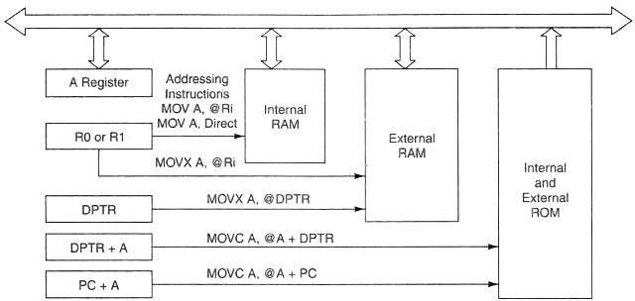

Fig no 3.0: Transferring Data Between Internal And External ROM

PUSH AND POP INSTRUCTIONS
Exchange instructions
The content of source ie., register, direct memory or indirect memory will be exchanged with the contents of destination ie., accumulator.
- XCH A,R3
- XCH A,@R1
- XCH A,54h
Exchange digit. Exchange the lower order nibble of Accumulator (A0-A3) with lower order nibble of the internal RAM location which is indirectly addressed by the register.
i. XCHD A,@R1
ii. XCHD A,@R0

Arithmetic instructions.
The 8051 can perform addition, subtraction. Multiplication and division operations on 8 bit numbers.

Addition
In this group, we have instructions to
Add the contents of A with immediate data with or without carry.
- ADD A, #45H
- ADDC A, #OB4H
- Add the contents of A with register Rn with or without carry.
- ADD A, R5
- ADDC A, R2
Add the contents of A with contents of memory with or without carry using direct and indirect addressing
ADDC A, 75H
ADD A, @R1
ADDC A, @R0

CY AC and OV flags will be affected by this operation.

Subtraction
In this group, we have instructions to
Subtract the contents of A with immediate data with or without carry.
SUBB A, #45H
SUBB A, #OB4H
Subtract the contents of A with register Rn with or without carry.
i. SUBB A, R5 ii. SUBB A, R2
Subtract the contents of A with contents of memory with or without carry using direct and indirect addressing
i. SUBB A, 51H ii. SUBB A, 75H
iii. SUBB A, @R1 iv. SUBB A, @R0

CY AC and OV flags will be affected by this operation.

Multiplication
MUL AB. This instruction multiplies two 8 bit unsigned numbers which are stored in A and B register. After multiplication the lower byte of the result will be stored in accumulator and higher byte of result will be stored in B register.

Division
DIV AB. This instruction divides the 8 bit unsigned number which is stored in A by the 8 bit unsigned number which is stored in B register. After division the result will be stored in accumulator and remainder will be stored in B register.

DA A (Decimal Adjust After Addition).

When two BCD numbers are added, the answer is a non-BCD number. To get the result in BCD, we use DA A instruction after the addition. DA A works as follows.
If lower nibble is greater than 9 or auxiliary carry is 1, 6 is added to lower nibble.
If upper nibble is greater than 9 or carry is 1, 6 is added to upper nibble.
Increment: increments the operand by one.

INC A INC Rn INC DIRECT INC @Ri INC DPTR

INC increments the value of source by 1. If the initial value of register is FFh, incrementing the value will cause it to reset to 0. The Carry Flag is not set when the value "rolls over" from 255 to 0.

In the case of "INC DPTR", the value two-byte unsigned integer value of DPTR is incremented. If the initial value of DPTR is FFFFh, incrementing the value will cause it to reset to 0.

Decrement: decrements the operand by one.

DEC A DEC Rn DEC DIRECT DEC @Ri
DEC decrements the value of source by 1. If the initial value of is 0, decrementing the value will cause it to reset to FFh. The Carry Flag is not set when the value “rolls over” from 0 to FFh.

LOGICAL INSTRUCTIONS

Logical AND
ANL destination, source: ANL does a bitwise “AND” operation between source and destination, leaving the resulting value in destination. The value in source is not affected. “AND” instruction logically AND the bits of source and destination.

Logical OR
ORL destination, source: ORL does a bitwise “OR” operation between source and destination, leaving the resulting value in destination. The value in source is not affected. “ OR “ instruction logically OR the bits of source and destination.
Logical Ex-OR
XRL destination, source: XRL does a bitwise “EX-OR” operation between source and destination, leaving the resulting value in destination. The value in source is not affected. “ XRL “ instruction logically EX-OR the bits of source and destination.
Logical NOT
CPL complements operand, leaving the result in operand. If operand is a single bit then the state of the bit will be reversed. If operand is the Accumulator then all the bits in the Accumulator will be reversed.
CPL A, CPL C, CPL bit address
SWAP A – Swap the upper nibble and lower nibble of A.
ROTATE INSTRUCTIONS RR A
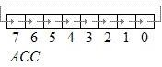
This instruction is rotate right the accumulator. Its operation is illustrated below. Each bit is shifted one location to the right, with bit 0 going to bit 7.
Fig no 3.1
RL A
Rotate left the accumulator. Each bit is shifted one location to the left, with bit 7 going to bit 0
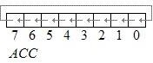
Fig no 3.2
RRC A
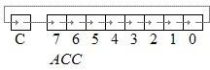
Rotate right through the carry. Each bit is shifted one location to the right, with bit 0 going into the carry bit in the PSW, while the carry was at goes into bit 7
Fig no 3.3

RLC A
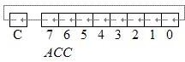
Rotate left through the carry. Each bit is shifted one location to the left, with bit 7 going into the carry bit in the PSW, while the carry goes into bit 0.
Fig no 3.4
BRANCH (JUMP) INSTRUCTIONS

Jump and Call Program Range
There are 3 types of jump instructions. They are
- Relative Jump
- Short Absolute Jump
- Long Absolute Jump
Relative Jump
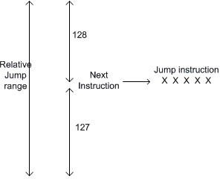
Jump that replaces the PC (program counter) content with a new address that is greater than (the address following the jump instruction by 127 or less) or less than (the address following the jump by 128 or less) is called a relative jump. Schematically, the relative jump can be shown as follows:
Fig no 3.5: Relative Jump
The advantages of the relative jump are as follows:-
- Only 1 byte of jump address needs to be specified in the 2's complement form, ie. For jumping ahead, the range is 0 to 127 and for jumping back, the range is -1 to -128.
- Specifying only one byte reduces the size of the instruction and speeds up program execution.
- The program with relative jumps can be relocated without reassembling to generate absolute jump addresses.
Disadvantages of the absolute jump: -
1. Short jump range (-128 to 127 from the instruction following the jump instruction) Instructions that use Relative Jump
SJMP <relative address>; this is unconditional jump The remaining relative jumps are conditional jumps JC <relative address>
JNC <relative address> JB bit, <relative address>
JNB bit, <relative address> JBC bit, <relative address>
CJNE <destination byte>, <source byte>, <relative address> DJNZ <byte>, <relative address>
JZ <relative address> JNZ <relative address>

Short Absolute Jump
In this case only 11bits of the absolute jump address are needed. The absolute jump address is calculated in the following manner.
In 8051, 64 kbyte of program memory space is divided into 32 pages of 2 kbyte each. The hexadecimal addresses of the pages are given as follows:-
It can be seen that the upper 5bits of the program counter (PC) hold the page number and the lower 11bits of the PC hold the address within that page. Thus, an absolute address is formed by taking page numbers of the instruction (from the program counter) following the jump and attaching the specified 11bits to it to form the 16-bit address.
Advantage: The instruction length becomes 2 bytes. Example of short absolute jump: -
ACALL <address 11>
AJMP <address 11>

Long Absolute Jump/Call
Applications that need to access the entire program memory from 0000H to FFFFH use long absolute jump. Since the absolute address has to be specified in the op-code, the instruction length is 3 bytes (except for JMP @ A+DPTR). This jump is not re-locatable.
Example: -
LCALL <address 16>
LJMP <address 16> JMP @A+DPTR

Another classification of jump instructions is
- Unconditional Jump
- Conditional Jump
The unconditional jump is a jump in which control is transferred unconditionally to the target location.
LJMP (long jump). This is a 3-byte instruction. First byte is the op-code and second and third bytes represent the 16-bit target address which is any memory location from 0000 to FFFFH eg: LJMP 3000H
AJMP: this causes unconditional branch to the indicated address, by loading the 11 bit address to 0 - 10 bits of the program counter. The destination must be therefore within the same 2K blocks.
SJMP (short jump). This is a 2-byte instruction. First byte is the op-code and second byte is the relative target address, 00 to FFH (forward +127 and backward -128 bytes from the current PC value). To calculate the target address of a short jump, the second byte is added to the PC value which is address of the instruction immediately below the jump.

Conditional Jump instructions.
JBC Jump if bit ＝ 1 and clear bit
JNB Jump if bit ＝ 0
JB Jump if bit ＝ 1
JNC Jump if CY ＝ 0
JC Jump if CY ＝ 1
CJNE reg,#data Jump if byte ≠ #data
CJNE A,byte Jump if A ≠ byte
DJNZ Decrement and Jump if A ≠ 0
JNZ Jump if A ≠ 0
JZ Jump if A ＝ 0
All conditional jumps are short jumps.
Bit level jump instructions:
Bit level JUMP instructions will check the conditions of the bit and if condition is true, it jumps to the address specified in the instruction. All the bit jumps are relative jumps.
JB bit, rel ; jump if the direct bit is set to the relative address specified. JNB bit, rel ; jump if the direct bit is clear to the relative address specified.
JBC bit, rel ; jump if the direct bit is set to the relative address specified and then clear the bit.

Subroutine CALL And RETURN Instructions

Subroutines are handled by CALL and RET instructions There are two types of CALL instructions
LCALL address(16 bit)
This is long call instruction which unconditionally calls the subroutine located at the indicated 16 bit address. This is a 3 byte instruction. The LCALL instruction works as follows.
During execution of LCALL, [PC] = [PC]+3; (if address where LCALL resides is say, 0x3254; during execution of this instruction [PC] = 3254h + 3h = 3257h
- [SP]=[SP]+1; (if SP contains default value 07, then SP increments and [SP]=08
- [[SP]] = [PC7-0]; (lower byte of PC content ie., 57 will be stored in memory location 08.
- [SP]=[SP]+1; (SP increments again and [SP]=09)
- [[SP]] = [PC15-8]; (higher byte of PC content ie., 32 will be stored in memory location 09.

- [PC]= address (16 bit); the new address of subroutine is loaded to PC. No flags are affected.

- ACALL address(11 bit)
- This is absolute call instruction which unconditionally calls the subroutine located at the indicated 11 bit address. This is a 2 byte instruction. The SCALL instruction works as follows.
- During execution of SCALL, [PC] = [PC]+2; (if address where LCALL resides is say, 0x8549; during execution of this instruction [PC] = 8549h + 2h = 854Bh
- [SP]=[SP]+1; (if SP contains default value 07, then SP increments and [SP]=08
- [[SP]] = [PC7-0]; (lower byte of PC content ie., 4B will be stored in memory location 08.
- [SP]=[SP]+1; (SP increments again and [SP]=09)
- [[SP]] = [PC15-8]; (higher byte of PC content ie., 85 will be stored in memory location 09.
- [PC10-0]= address (11 bit); the new address of subroutine is loaded to PC. No flags are affected.

- RET instruction
RET instruction pops top two contents from the stack and load it to PC.
- [PC15-8] = [[SP]] ;content of current top of the stack will be moved to higher byte of PC. h. [SP]=[SP]-1; (SP decrements)
- [PC7-0] = [[SP]] ;content of bottom of the stack will be moved to lower byte of PC.
- [SP]=[SP]-1; (SP decrements again)

BIT MANIPULATION INSTRUCTIONS.

8051 has 128 bit addressable memory. Bit addressable SFRs and bit addressable PORT pins. It is possible to perform following bit wise operations for these bit addressable locations.
LOGICAL AND
ANL C,BIT(BIT ADDRESS)
ANL C, /BIT;
LOGICAL OR
ORL C,BIT(BIT ADDRESS) ; ‘LOGICALLY OR’ CARRY AND CONTENT OF BIT ADDRESS, STORE RESULT IN CARRY
ORL C, /BIT; ; ‘LOGICALLY OR’ CARRY AND COMPLEMENT OF CONTENT OF BIT ADDRESS, STORE RESULT IN CARRY

- CLR bit
- CLR bit .
- CLR C
- CPL bit
- CPL bit .
- CPL C
- COMPLEMENTED.

ASSEMBLY LANGUAGE PROGRAMS.
Write a program to add the values of locations 50H and 51H and store the result in locations in 52h and 53H.

ORG 0000H ; Set program counter 0000H
MOV A,50H ; Load the contents of Memory location 50H into A ADD ADD A,51H
; Add the contents of memory 51H with CONTENTS A MOV 52H,A ; Save the LS byte of the result in 52H
MOV A, #00 ; Load 00H into A
ADDC A, #00 ; Add the immediate data and carry to A MOV 53H,A ; Save the MS byte of the result in location 53h
END

Write a program to store data FFH into RAM memory locations 50H to 58H using direct addressing mode

ORG 0000H ; Set program counter 0000H
MOV A, #0FFH ; Load FFH into A
MOV 50H, A ; Store contents of A in location 50H
MOV 51H, A ; Store contents of A in location 5IH
MOV 52H, A ; Store contents of A in location 52H
MOV 53H, A ; Store contents of A in location 53H
MOV 54H, A ; Store contents of A in location 54H
MOV 55H, A ; Store contents of A in location 55H
MOV 56H, A ; Store contents of A in location 56H

MOV 57H, A ; Store contents of A in location 57H
MOV 58H, A ; Store contents of A in location 58H
END

BASICS OF INTERRUPTS.
During program execution if peripheral devices needs service from microcontroller, device will generate interrupt and gets the service from microcontroller. When peripheral device activate the interrupt signal, the processor branches to a program called interrupt service routine. After executing the interrupt service routine the processor returns to the main program.
Steps taken by processor while processing an interrupt:

- It completes the execution of the current instruction.
- PSW is pushed to stack.
- PC content is pushed to stack.
- Interrupt flag is reset.
- PC is loaded with ISR address.

ISR will always ends with RETI instruction. The execution of RETI instruction results in the following.

- POP the current stack top to the PC.
- POP the current stack top to PSW.

External and internal interrupts.
External interrupts are those initiated by peripheral devices through the external pins of the microcontroller. Internal interrupts are those activated by the internal peripherals of the microcontroller like timers, serial controller etc.)
- Maskable and non-maskable interrupts.
The category of interrupts which can be disabled by the processor using program is called maskable interrupts.
Non-maskable interrupts are those category by which the programmer cannot disable it using program.
- Vectored and non-vectored interrupt.
Starting address of the ISR is called interrupt vector. In vectored interrupts the starting address is predefined. In non-vectored interrputs, the starting address is provided by the peripheral as follows.
- Microcontroller receives an interrupt request from external device.
- Controller sends an acknowledgement (INTA) after completing the execution of current instruction.
The peripheral device sends the interrupt vector to the microcontroller.

8051 INTERRUPT STRUCTURE.

8051 has five interrupts. They are maskable and vectored interrupts. Out of these five, two are external interrupt and three are internal interrupts.

External interrupt 0 | External | 0003 | Highest
Timer 0 interrupt | Internal | 000B
External interrupt 1 | External | 0013
Timer 1 interrupt | Internal | 001B
Serial interrupt | Internal | 0023 | Lowest

INTRODUCTION
CHAPTER-4.C-LANGUAGE

The C Language is developed by Dennis Ritchie for creating system applications that directly interact with the hardware devices such as drivers, kernels, etc.
C programming is considered as the base for other programming languages, that is why it is known as mother language
#include <stdio.h>
int main() {
printf("Hello C Programming\n");
return 0;
}
Features of C Language
C features
C is the widely used language. It provides many features that are given below
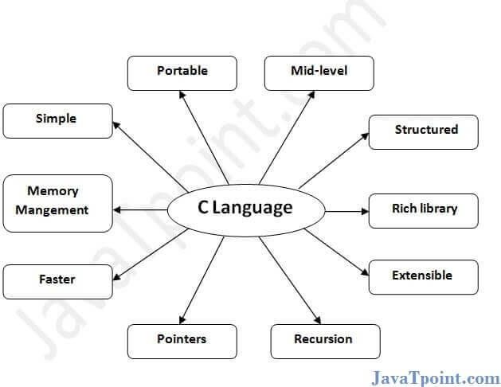
Fig no 4.0: C language
Simple
Machine Independent or Portable
Mid-level programming language
structured programming language
Rich Library
Memory Management
Fast Speed
Pointers
Recursion

ELEMENTS OF C LANGUAGE
Before going in depth, we need to understand the basic elements of c language. It is very necessary to know these elements because it helps you to write c program. In below list, I have listed some important elements of C language.
Functions.
Variables.
Statements.
Comments.
Programiz
Character set
A character set is a set of alphabets, letters and some special characters that are valid in C language.
Alphabets
Uppercase: A B C X Y Z
Lowercase: a b c x y z
C accepts both lowercase and uppercase alphabets as variables and functions.
Digits
0 1 2 3 4 5 6 7 8 9
Special Characters
Special Characters in C Programming

, | < | > | . | _
( | ) | ; | $ | :
% | [ | ] | # | ?
' | & | { | } | "
^ | ! | * | / | |
- | \ | ~ | +
White space Characters
Blank space, newline, horizontal tab, carriage return and form feed.
C Keywords
Keywords are predefined, reserved words used in programming that have special meanings to the compiler. Keywords are part of the syntax and they cannot be used as an identifier. For example:
int money;
Here, int is a keyword that indicates money is a variable of type int (integer).
As C is a case sensitive language, all keywords must be written in lowercase. Here is a list of all keywords allowed in ANSI C.

C Keywords
auto double int struct
break else long switch
case enum registertypedef
char extern return union
continue for signed void
do if static while
default goto sizeof volatile
const float short unsigned
All these keywords, their syntax, and application will be discussed in their respective topics.
C Identifiers
Identifier refers to name given to entities such as variables, functions, structures etc.
Identifiers must be unique. They are created to give a unique name to an entity to identify it during the execution of the program. For example:
int money;
double accountBalance;
Here, money and accountBalance are identifiers.
Also remember, identifier names must be different from keywords. You cannot use int as an identifier because int is a keyword.
Rules for naming identifiers
- A valid identifier can have letters (both uppercase and lowercase letters), digits and underscores.
- The first letter of an identifier should be either a letter or an underscore.
- You cannot use keywords like int, while etc. as identifiers.
- There is no rule on how long an identifier can be. However, you may run into problems in some compilers if the identifier is longer than 31 characters.
- You can choose any name as an identifier if you follow the above rule, however, give meaningful names to identifiers that make sense.
C Data Types
In this tutorial, you will learn about basic data types such as int, float, char etc. in C programming.

In C programming, data types are declarations for variables. This determines the type and size of data associated with variables. For example,
int myVar;
Here, myVar is a variable of int (integer) type. The size of int is 4 bytes.

BASIC TYPES
Here's a table containing commonly used types in C programming for quick access.
Type Size (bytes) Format Specifier
int at least 2, usually 4 %d, %i
char 1 %c
float 4 %f
double 8 %lf
short int 2 usually %hd
unsigned int at least 2, usually 4 %u
long int at least 4, usually 8 %ld, %li
long long int at least 8 %lld, %lli
unsigned long int at least 4 %lu
unsigned long long int at least 8 %llu
signed char 1 %c
unsigned char 1 %c
long double at least 10, usually 12 or 16 %Lf

int
Integers are whole numbers that can have both zero, positive and negative values but no decimal values. For example, 0, -5, 10
We can use int for declaring an integer variable.
int id;
Here, id is a variable of type integer.
You can declare multiple variables at once in C programming. For example,
int id, age;
The size of int is usually 4 bytes (32 bits). And, it can take 232 distinct states from -2147483648 to 2147483647.
float and double
float and double are used to hold real numbers. float salary;
double price;
In C, floating-point numbers can also be represented in exponential. For example, float normalization Factor = 22.442e2;

What's the difference between float and double?
The size of float (single precision float data type) is 4 bytes. And the size of double (double precision float data type) is 8 bytes.
char
Keyword char is used for declaring character type variables. For example, char test = 'h';
The size of the character variable is 1 byte.

void
void is an incomplete type. It means "nothing" or "no type". You can think of void as absent. For example, if a function is not returning anything, its return type should be void.
Note that, you cannot create variables of void type.

short and long
If you need to use a large number, you can use a type specifier long. Here's how:
long a;
long long b;
long double c;
Here variables a and b can store integer values. And, c can store a floating-point number.
If you are sure, only a small integer ([−32,767, +32,767] range) will be used, you can use short. short d;

You can always check the size of a variable using the sizeof() operator.
#include <stdio.h>
int main() {
short a;
long b;
long long c;
long double d;
printf("size of short = %d bytes\n", sizeof(a));
printf("size of long = %d bytes\n", sizeof(b));
printf("size of long long = %d bytes\n", sizeof(c));
printf("size of long double= %d bytes\n", sizeof(d));
return 0;
}
signed and unsigned
In C, signed and unsigned are type modifiers. You can alter the data storage of a data type by using them. For example,

unsigned int x;
int y;
Here, the variable x can hold only zero and positive values because we have used the unsigned modifier. Considering the size of int is 4 bytes, variable y can hold values from -231 to 231,whereas variable x can hold values from 0 to 232-1.
Constants
If you want to define a variable whose value cannot be changed, you can use the const keyword. This will create a constant. For example,
const double PI = 3.14;
Notice, we have added keyword const.
Here, PI is a symbolic constant; its value cannot be changed. const double PI = 3.14;
PI = 2.9; //Error
Variables
In programming, a variable is a container (storage area) to hold data.
To indicate the storage area, each variable should be given a unique name (identifier). Variable names are just the symbolic representation of a memory location. For example:
int playerScore = 95;
Here, playerScore is a variable of int type. Here, the variable is assigned an integer value 95.

The value of a variable can be changed, hence the name variable. char ch = 'a';
// some code ch = 'l';
Rules for naming a variable
- A variable name can only have letters (both uppercase and lowercase letters), digits and underscore.
- The first letter of a variable should be either a letter or an underscore.
- There is no rule on how long a variable name (identifier) can be. However, you may run into problems in some compilers if the variable name is longer than 31 characters.
Note: You should always try to give meaningful names to variables. For example: firstName is a better variable name than fn.
C is a strongly typed language. This means that the variable type cannot be changed once it is declared. For example:
int number = 5; // integer variable
number = 5.5; // error

double number; // error
Here, the type of number variable is int. You cannot assign a floating-point (decimal) value 5.5 to this variable. Also, you cannot redefine the data type of the variable to double. By the way, to store the decimal values in C, you need to declare its type to either double or float.
Chapter-2.C Input Output (I/O)
In this tutorial, you will learn to use scanf() function to take input from the user, and printf() function to display output to the user.

C-OUTPUT
In C programming, printf() is one of the main output function. The function sends formatted output to the screen. For example,
Example 1: C Output
#include <stdio.h>
int main()
{
// Displays the string inside quotations
printf("C Programming");
return 0;
}
Output
C Programming
How does this program work?
All valid C programs must contain the main() function. The code execution begins from the start of the main() function.
The printf() is a library function to send formatted output to the screen. The function prints the string inside quotations.
To use printf() in our program, we need to include stdio.h header file using the #include <stdio.h> statement. The return 0; statement inside the main() function is the "Exit status" of the program. It's optional.
Example 2: Integer Output
#include <stdio.h>
int main()
{
int testInteger = 5;
printf("Number = %d", testInteger);
return 0;
}
Output
Number = 5
We use %d format specifier to print int types. Here, the %d inside the quotations will be replaced by the value of testInteger.
Example 3: float and double Output
#include <stdio.h>
int main()
{
float number1 = 13.5; double number2 = 12.4;

printf("number1 = %f\n", number1);
printf("number2 = %lf", number2); return 0;
}
Output
number1 = 13.500000
number2 = 12.400000
To print float, we use %f format specifier. Similarly, we use %lf to print double values.

Example 4: Print Characters
#include <stdio.h>
int main()
{
char chr = 'a';
printf("character = %c", chr); return 0;
}
Output
character = a
To print char, we use %c format specifier.

C INPUT
In C programming, scanf() is one of the commonly used function to take input from the user. The scanf() function reads formatted input from the standard input such as keyboards.
Example 5: Integer Input/Output
#include <stdio.h>
int main()
{
int testInteger;
printf("Enter an integer: ");
scanf("%d", &testInteger);
printf("Number = %d",testInteger);
return 0;
}
Output
Enter an integer: 4 Number = 4
Here, we have used %d format specifier inside the scanf() function to take int input from the user. When the user enters an integer, it is stored in the testInteger variable.
Notice, that we have used &testInteger inside scanf(). It is because &testInteger gets the address of testInteger, and the value entered by the user is stored in that address.
Example 6: Float and Double Input/Output
#include <stdio.h>
int main()
{
float num1; double num2;
printf("Enter a number: ");
scanf("%f", &num1);
printf("Enter another number: ");
scanf("%lf", &num2);
printf("num1 = %f\n", num1);
printf("num2 = %lf", num2);
return 0;
}
Output
Enter a number: 12.523
Enter another number: 10.2 num1 = 12.523000
num2 = 10.200000
We use %f and %lf format specifier for float and double respectively.
Example 7: C Character I/O
#include <stdio.h>
int main()
{
char chr;
printf("Enter a character: ");
scanf("%c",&chr);
printf("You entered %c.", chr);
return 0;
}
Output
Enter a character: g You entered g
When a character is entered by the user in the above program, the character itself is not stored. Instead, an integer value (ASCII value) is stored.
And when we display that value using %c text format, the entered character is displayed. If we use %d to display the character, it's ASCII value is printed.
Example 8: ASCII Value
#include <stdio.h>
int main()
{
char chr;
printf("Enter a character: ");
scanf("%c", &chr);
// When %c is used, a character is displayed
printf("You entered %c.\n",chr);
// When %d is used, ASCII value is displayed
printf("ASCII value is %d.", chr);
return 0;
}
Output

Enter a character: g You entered g.
ASCII value is 103. I/O Multiple Values
Here's how you can take multiple inputs from the user and display them.

#include <stdio.h>
int main()
{
int a; float b;
printf("Enter integer and then a float: ");
// Taking multiple inputs
scanf("%d%f", &a, &b);
printf("You entered %d and %f", a, b);
return 0;
}
Output
Enter integer and then a float: -3 3.4
You entered -3 and 3.400000 Format Specifiers for I/O
As you can see from the above examples, we use
%d for int
%f for float
%lf for double
%c for char
Here's a list of commonly used C data types and their format specifiers.

Data | Type | Format Specifier
int | %d
char | %c
float | %f
double %lf
short int %hd
unsigned int %u
long int %li
long long int %lli
unsigned long int %lu
unsigned long long int%llu
signed char %c
unsigned char %c
long double

C if Statement
The syntax of the if statement in C programming is: if (test expression)
{
// statements to be executed if the test expression is true
}
How if statement works?
- The if statement evaluates the test expression inside the parenthesis ().
- If the test expression is evaluated to true, statements inside the body of if are executed.
- If the test expression is evaluated to false, statements inside the body of if are not executed
C if...else Statement
The if statement may have an optional else block. The syntax of the if..else statement is: if (test expression) {
// statements to be executed if the test expression is true
}
else {
// statements to be executed if the test expression is false
}
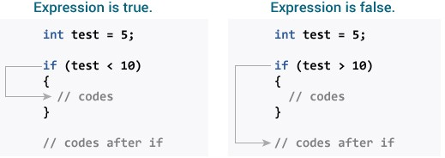
Fig no 4.1: if else statement

How if...else statement works?
- If the test expression is evaluated to true,
- statements inside the body of if are executed.
- statements inside the body of else are skipped from execution.
- If the test expression is evaluated to false,
- statements inside the body of else are executed
- statements inside the body of if are skipped from execution.
while loop
The syntax of the while loop is:
while (testExpression)
{
// statements inside the body of the loop
}
How while loop works?

- The while loop evaluates the test expression inside the parenthesis ().
- If the test expression is true, statements inside the body of while loop are executed. Then, the test expression is evaluated again.
- The process goes on until the test expression is evaluated to false.
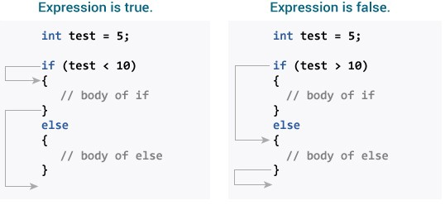
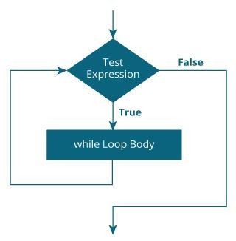
Fig no 4.2: working of while loop

If the test expression is false, the loop terminates (ends).
Example 1: while loop
// Print numbers from 1 to 5
#include <stdio.h>
int main()
{
int i = 1;
hile (i <= 5)
{
printf("%d\n", i);
++i;
}
return 0;
}
Output 1
2
3
4
5

do...while loop

The do..while loop is similar to the while loop with one important difference. The body of do...while loop is executed at least once. Only then, the test expression is evaluated.
The syntax of the do...while loop is: do
{
// statements inside the body of the loop
}
while (test Expression);
How do...while loop works?
- The body of do...while loop is executed once. Only then, the test expression is evaluated.
- If the test expression is true, the body of the loop is executed again and the test expression is evaluated.

- This process goes on until the test expression becomes false.
- If the test expression is false, the loop ends.
Flowchart of do...while Loop
do while loop flowchart in C programming Example 2: do...while loop
// Program to add numbers until the user enters zero
#include <stdio.h>
int main()
{
double number, sum = 0;
// the body of the loop is executed at least once do
{
printf("Enter a number: ");
scanf("%lf", &number); sum += number;
}
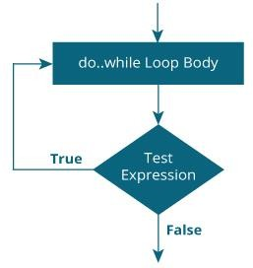

Fig no 4.3: while loop

while(number != 0.0);
printf("Sum = %.2lf",sum); return 0;
}
Output
Enter a number: 1.5
Enter a number: 2.4
Enter a number: -3.4
Enter a number: 4.2
Enter a number: 0
Sum = 4.70
for Loop
The syntax of the for loop is:
for (initializationStatement; testExpression; updateStatement)
{
// statements inside the body of loop
}
How for loop works?
The initialization statement is executed only once.
Then, the test expression is evaluated. If the test expression is evaluated to false, the for loop is terminated.
However, if the test expression is evaluated to true, statements inside the body of for loop are executed, and the update expression is updated.
Again the test expression is evaluated.
This process goes on until the test expression is false. When the test expression is false, the loop terminates.

example 1: for loop
// Print numbers from 1 to 10
#include <stdio.h>
int main() { int i;
for (i = 1; i < 11; ++i)
{
printf("%d ", i);
}
return 0;
}
Output
1 2 3 4 5 6 7 8 9 10
C break
The break statement ends the loop immediately when it is encountered. Its syntax is: break;
The break statement is almost always used with if...else statement inside the loop. How break statement works?
Working of break statement

Example 1: break statement
// Program to calculate the sum of numbers (10 numbers max)
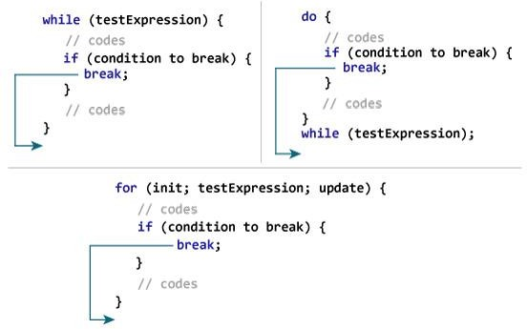
Fig no 4.4: Break statement
// If the user enters a negative number, the loop terminates
#include <stdio.h>
int main()
{
int i;
double number,
sum = 0.0; for (i = 1; i <= 10; ++i) {
printf("Enter a n%d: ", i);
scanf("%lf", &number);
// if the user enters a negative number, break the loop if (number < 0.0)
{
break;
}
sum += number; // sum = sum + number;
}
printf("Sum = %.2lf", sum); return 0;
}
Output
Enter a n1: 2.4
Enter a n2: 4.5
Enter a n3: 3.4
Enter a n4: -3
Sum = 10.30
C continue
The continue statement skips the current iteration of the loop and continues with the next iteration. Its syntax is:
continue;
The continue statement is almost always used with the if...else statement. How continue statement works?
Working of continue statement in C programming
Example 2: continue statement
// Program to calculate the sum of numbers (10 numbers max)
// If the user enters a negative number, it's not added to the result #include <stdio.h>
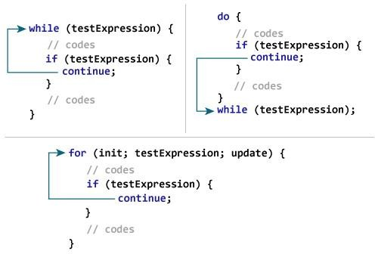
fig no 4.5: continue statement
int main() {
int i;
double number, sum = 0.0;
for (i = 1; i <= 10; ++i) {
printf("Enter a n%d: ", i);
scanf("%lf", &number);
if (number < 0.0) {
continue;
}
sum += number; // sum = sum + number;
}
printf("Sum = %.2lf", sum);
return 0;
}
Output
Enter a n1: 1.1
Enter a n2: 2.2
Enter a n3: 5.5
Enter a n4: 4.4
Enter a n5: -3.4
Enter a n6: -45.5
Enter a n7: 34.5
Enter a n8: -4.2
Enter a n9: -1000
Enter a n10: 12
Sum = 59.7

C Functions
In c, we can divide a large program into the basic building blocks known as function. The function contains the set of programming statements enclosed by {}. A function can be called multiple times to provide reusability and modularity to the C program. In other words, we can say that the collection of functions creates a program. The function is also known as procedureor subroutinein other programming languages. Advantage of functions in C
- There are the following advantages of C functions.
- By using functions, we can avoid rewriting same logic/code again and again in a program.
- We can call C functions any number of times in a program and from any place in a program.
- We can track a large C program easily when it is divided into multiple functions.
- Reusability is the main achievement of C functions.
- However, Function calling is always a overhead in a C program.
Types of Functions
There are two types of functions in C programming:
Library Functions: are the functions which are declared in the C header files such as scanf(), printf(), gets(), puts(), ceil(), floor() etc.
User-defined functions: are the functions which are created by the C programmer, so that he/she can use it many times. It reduces the complexity of a big program and optimizes the code.

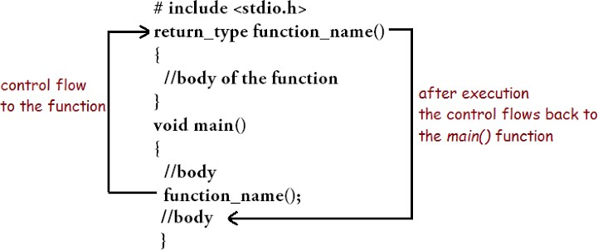

Fig no 4.6: Types of Functions
C Function Return Value
A C function ma he function, use void for the return type.
Let's see a simple example of C function that doesn't return any value from the function
Example 1
#include<stdio.h>
void printName();
void main ()
{
printf("Hello "); printName();
}
void printName()
{
printf("Javatpoint");
}
Output:
Javatpoint

CHAPTER -5 KEIL SOFTWARE :

INTRODUCTION :
- Keil was invented by Carl Friedrich Keil.
- Keil Micro Vision is a free software which solves many of the pain points for an embedded program developer. This software is an integrated development environment (IDE), which integrated a text editor to write programs, a compiler and it will convert your source code to hex files too.
- Here is simple guide to start working with Keil uVision which can be used for.

- Writing programs in C/C++ or Assembly language.

- Compiling and Assembling Programs.

- Debugging program.

- Creating Hex and Axf file.

- Testing your program without Available real Hardware (Simulator Mode).

- This is simple guide on Keil uVision 4 though also applicable on previous versions also.

PROCESS TO USE KEIL SOFTWARE :
These are the simple steps to get off the mark your inning!
Step 1: After opening Keil uV4, Go to Project tab and Create new uVision project.
Now Select new folder and give name to Project.

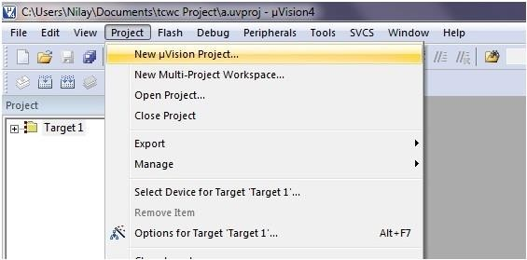
Fig no.5.1: Creating New uvision Project

Step 2: After Creating project now Select your device model. Example. Atmel
[You can change it later from project window.]

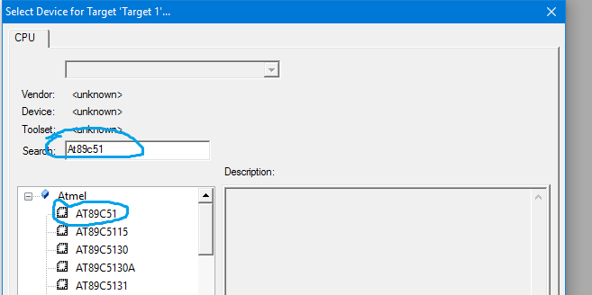
Fig no.5.2: selection of device

Step 3: so now your project is created and Message window will appear to add startup file of your Device click on Yes so it will be added to your project folder.

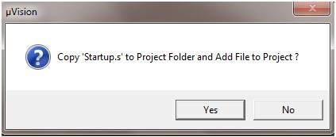
Fig no.5.3: Asking to add startup file or not

Step 4: Now go to File and create new file and save it with .C extension if you will write program in C language or save with .asm for assembly language.
i.e., Led.c

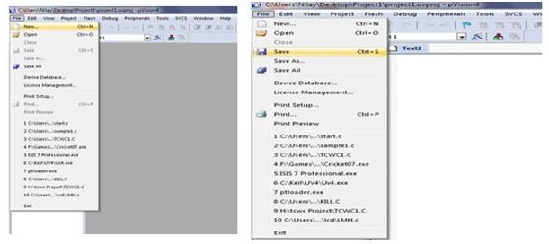

Fig no.5.4: creation of new file

Step 5: Now write your program and save it again. You can try example given at end of this tutorial.
Step 6: After that on left you see project window [if it’s not there go to View tab and click on project window].
Now come on Project window.

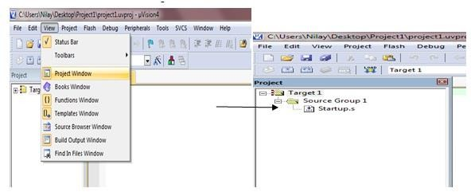

Fig no.5.5: selecting project window

Right click on target and click on options for target.
Here you can change your device also.
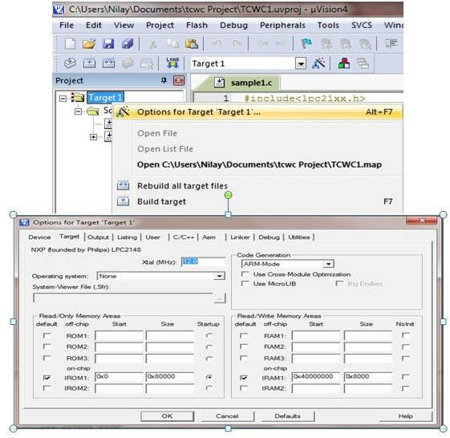

Fig no.5.6: creating a target file
Click output tab here & check create Hex file if you want to generate hex file.
Now click on ok so it will save changes.
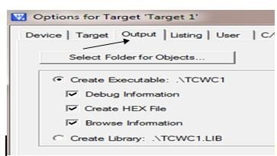
Fig no.5.7: creation of Hex file

Step 7: Now Expand target and you will see source group.
Right click on group and click on Add files to source group.

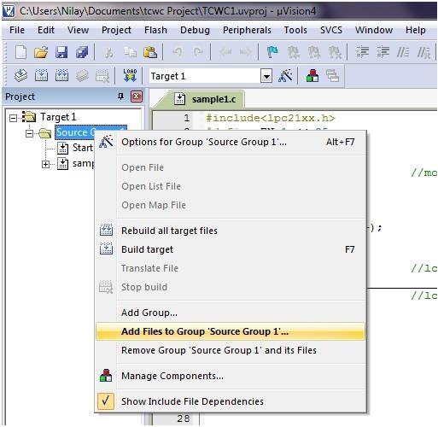
Fig no.5.8: Adding files to source group

Now add your program file which you have written in C/assembly.
You can see program file added under source group.
Step 8: Now Click on Build target.You can find it under Project tab or in toolbar .It can also be done by pressing F7 key.

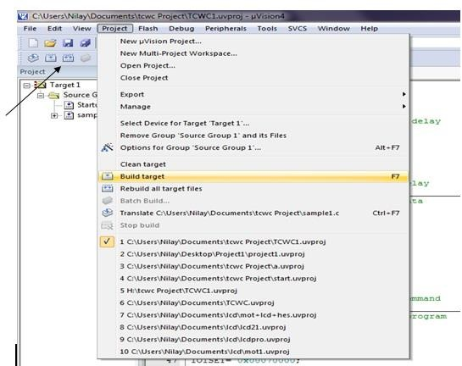

Fig no. 5.9 :Building an Target
Step 9: you can see Status of your program in Build output window
[If it’s not there go to view and click on Build output window]

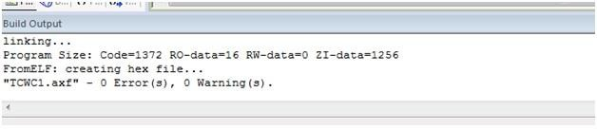
Fig no. 5.10 : checking for errors and warnings

Now you are done with your program. Next time we will look at Debugging and Simulation of Program.

