PROTEUS STIMULATION SOFTWARE :
INTRODUCTION :
- Proteus is used to simulate, design and drawing of electronic circuits. It was invented by the Labcenter electronic.
- By using proteus you can make two-dimensional circuits designs as well.

- With the use of this engineering software, you can construct and simulate different electrical and electronic circuits on your personal computers or laptops.
- There are numerous benefits to simulate circuits on proteus before make them practically.

- Designing of circuits on the proteus takes less time than practical construction of the circuit.

- The possibility of error is less in software simulation such as loose connection that takes a lot of time to find out connections problems in a practical circuit.
- Circuit simulations provide the main feature that some components of circuits are not practical then you can construct your circuit on proteus.
- There is zero possibility of burning and damaging of any electronic component in proteus.

- The electronic tools that are very expensive can easily get in proteus such as an oscilloscope.

- Using proteus you can find different parents of circuits such as current, a voltage value of any component and resistance at any instant which is very difficult in a practical circuit.

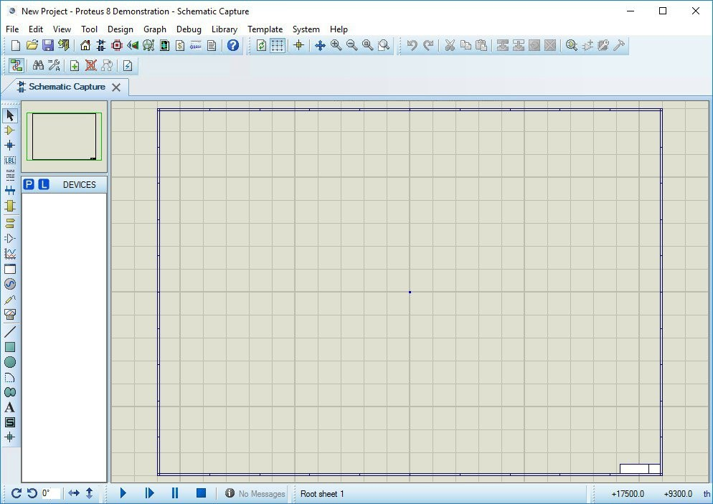
Fig no.6.1 : schematic window of proteus

FEATURES OF PROTEUS :
- There are 2 main parts of proteus first is used to design and draw different circuits and the second is for designing of PCB layout.
- First is ISIS that used to design and simulate circuits. And second is ARES that used for designing of a printed circuit board.
- It also provides features related to the three-dimensional view of design in PCB.

16.3 PCB LAYOUT :

- Now we discuss the layout of proteus and will discuss sections and their functionality in proteus.

- When you will click on the Icon of installed Proteus in your computer then you will see this window from a new file option.
- In the above figure, you can see the proteus window and this window has many sections that are explained in the below .
EDITING WINDOW :

In the above figure, you can see that the dotted portion is called an editing window. This is a drawing portion of proteus where you simulate your engineering circuits and projects.
OVERVIEW WINDOW :
In the overview window, you see the complete view of your complete design.
OBJECT SELECTOR :

This section has 2 buttons P and E. P is used to select different components and shown in this box. The E button is for edit something for example you want to vary any value of components than you can use this edit button.
ZOOM OPTION :
By using this option you can easily zoom in and zoom out your layout and can observe complete simulation very clearly
TOOL OPTION :
By using this option you can select different devices like voltmeter, ammeter, oscilloscope, etc.
RUN BUTTONS :
At the left bottom there are 4 buttons Run, stop, pause and stop. These buttons are like the remote control and on and off your circuit.

HOW TO MAKE CIRCUIT IN PROTEUS :

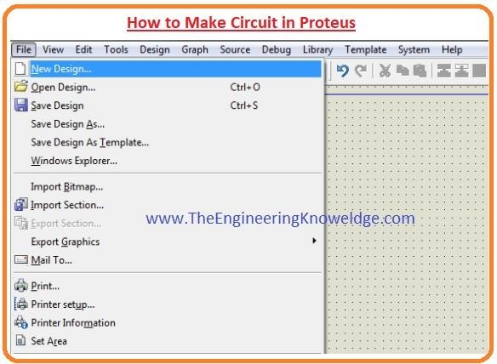
Step 1: First of all click on proteus Icon in your computer and click on a new file option as shown in the below figure.
Fig no.6.2 : creation of new file

Step 2: After that, you will see the drawing sheet as shown in the below figure. Save it according to your project.

Fig no.6.2 : saving a file

Step 3: After a move to the component option as shown in the below figure and select the elements for your projects.

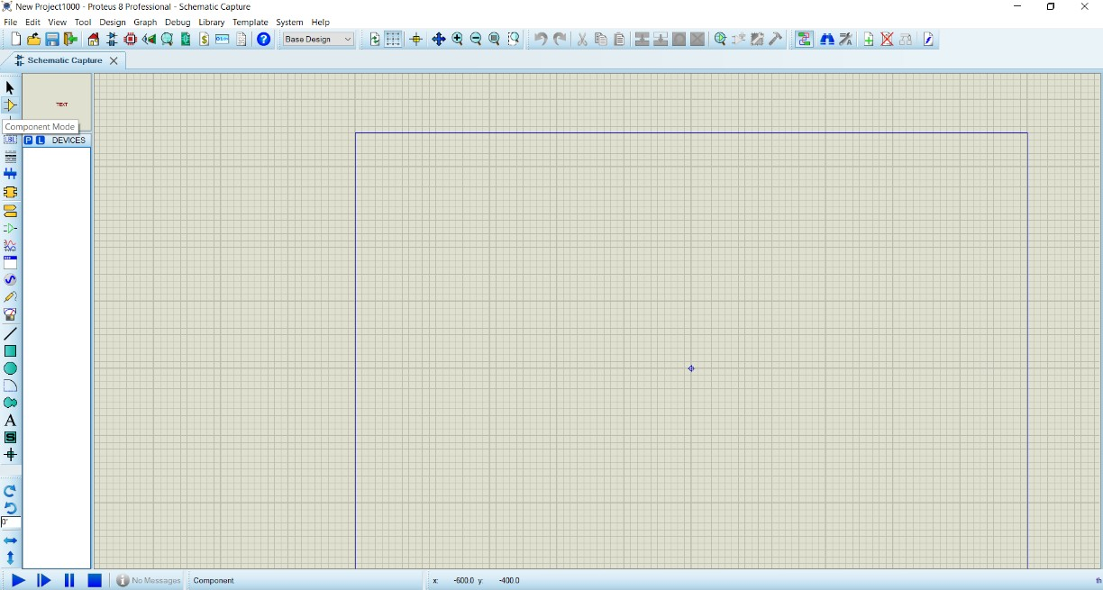
.
Fig no.6.3 :Selection of component mode

Step 4: After clicking on components mode you will see two buttons P and L. If you move to P button you will see Pic from Libraries. It is used to select different components for circuit construction.
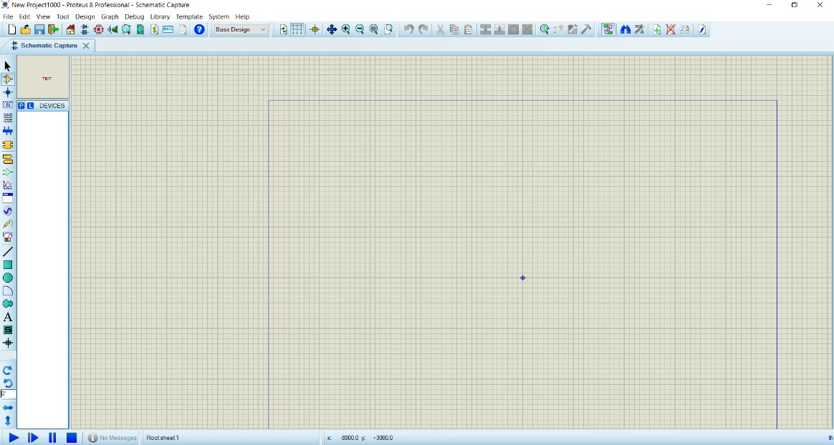

Fig no. 6.4 selecting the P

Step 5: When you will click on the P button you will see box shown in the below figure. Type your component for a circuit. As I type button and you can see a button in right figure that different buttons are shown you can select according to your use.

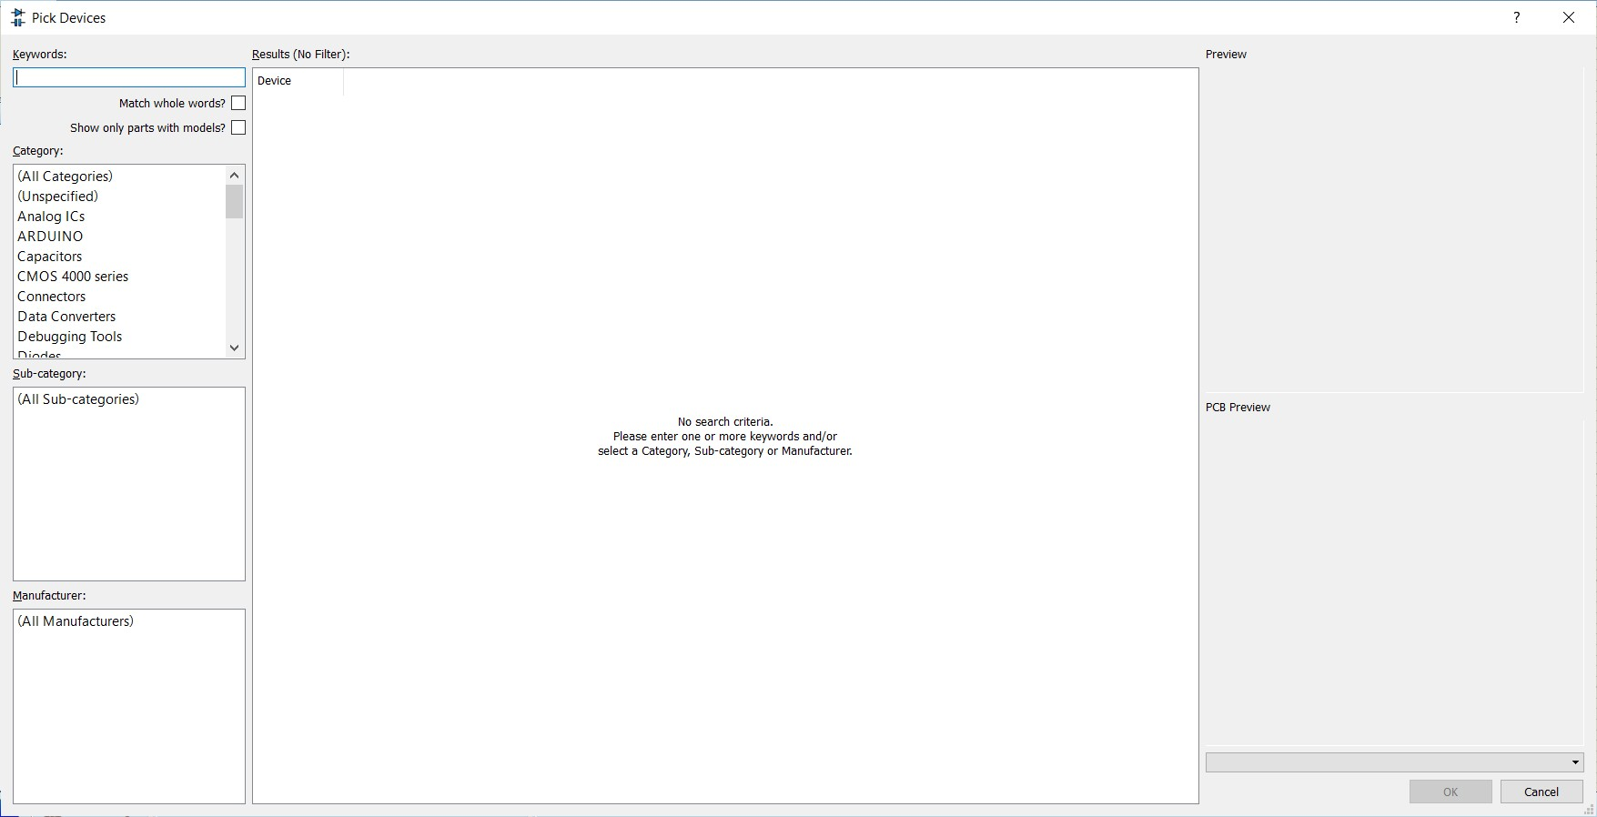

Fig no. 6.5 : Typing the components

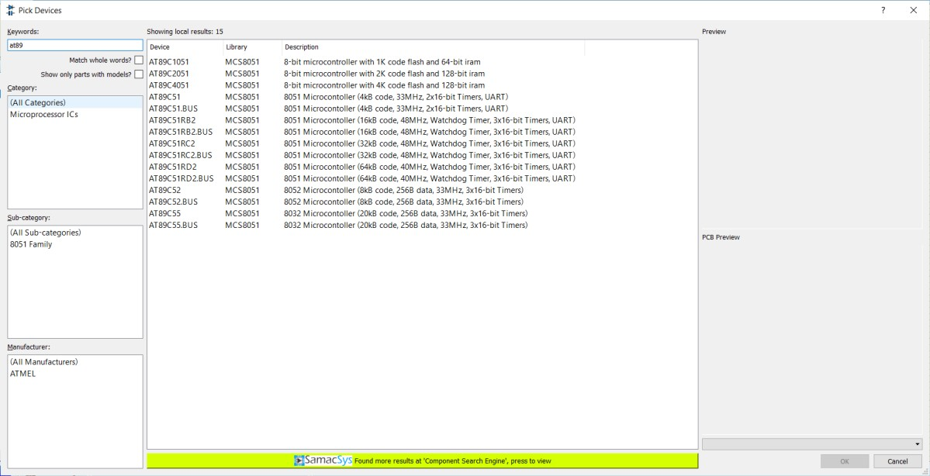
Fig no. 6. : selecting the components

Step 6:When you will select components for your project you will see them in a box shown in the below figure.I have also selected some components for designing of a simple circuit.
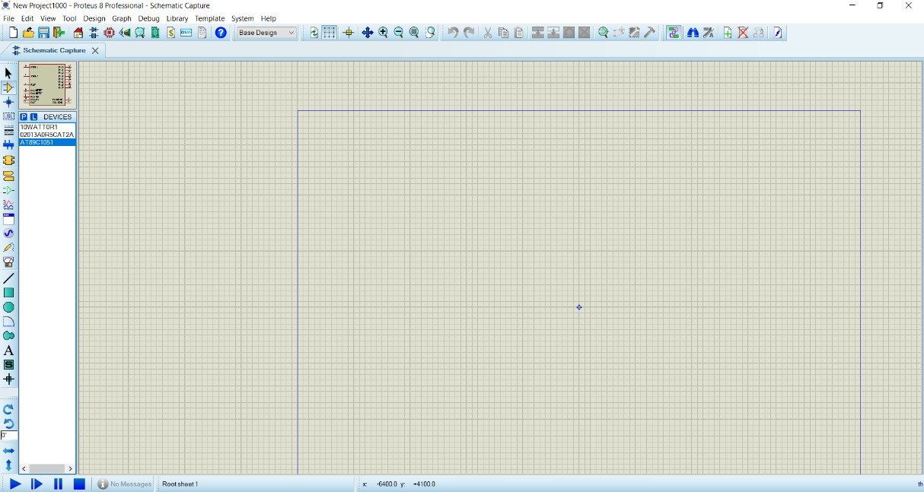
Fig no. 6.7 : selection of components for designing the schematic

After the selection of components make the circuit layout of your project and connect all these components with the wires.
For connection of one component to other clicks left of first one terminal of component and drag it to other components.
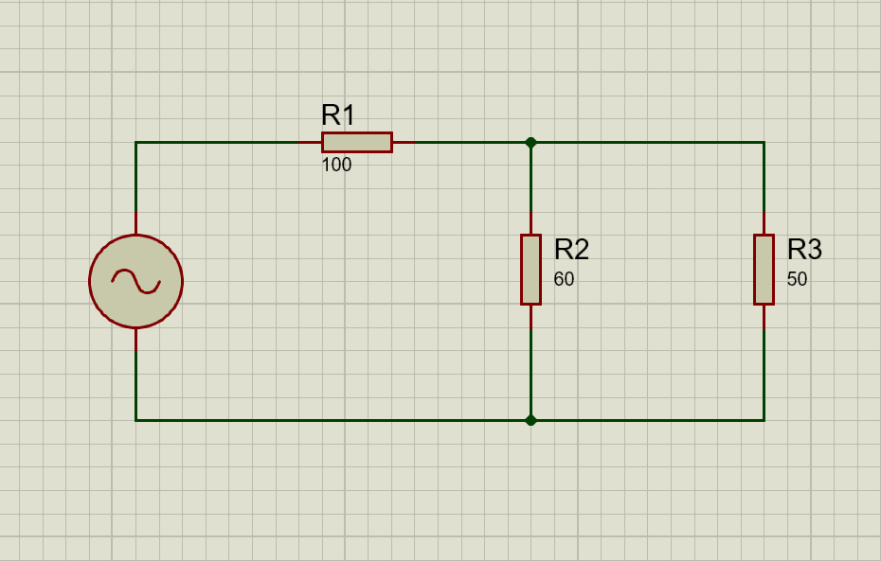
If you want to remove any component or remove its connection just double click on respective of a component
Fig no. 6.8 : sketching the circuit

If you want to change the values of any component such as resistance, capacitor, then click right on that component and select the desired value and click OK button.
As in the below figure, I vary the value of battery voltages.

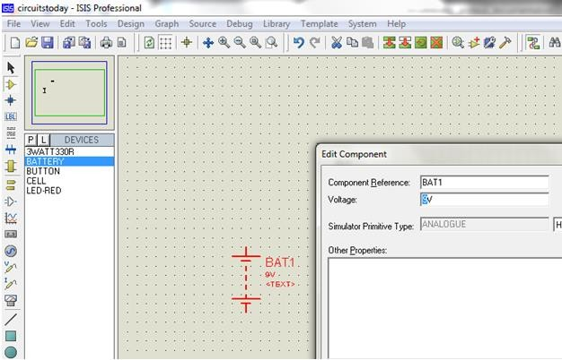

Fig no. 6.9 : Editing the components values

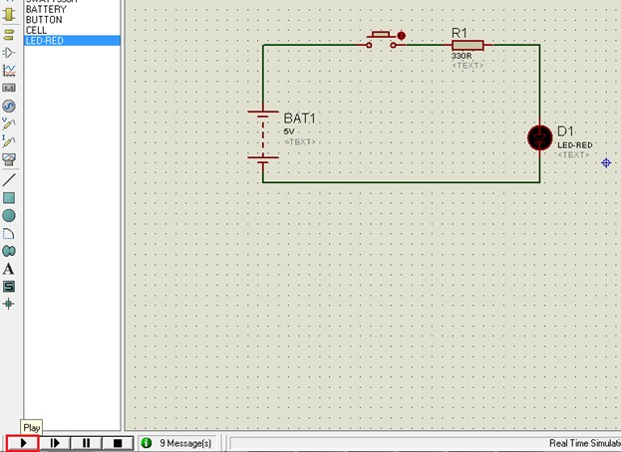
Step 7: When you connect all components in the circuit like run button in left bottom see the practical working of your circuit.

Fig no. 6.10 : Running the circuit

Step 8: When you will observe the simulation of your circuit than click on stop button on the left bottom to stop the working of the circuit.

PROCESS TO CREATE PCB LAYOUT :

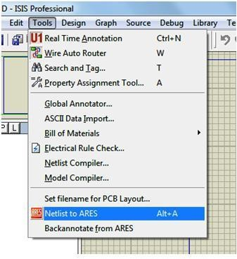
Now we are going to design a PCB layout for the above circuit. Proteus has the integrated ARES PCB designing suit. By using this we can easily develop the PCB layout. After simulation save the circuit designing and click on tools then select netlist to ARES. Then a window will open with list of component packages. That is shown in below image.

Fig no. 6.11 : selection of Netlist to Ares
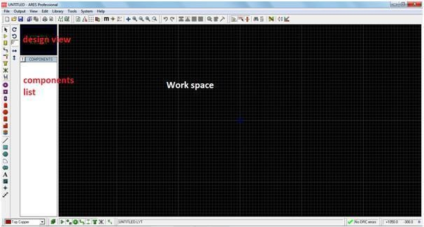

Fig no. 6.12 : PCB layout window

Then next step is creating a board edge by selecting 2D graphics box mode. Next click on the select layer at bottom left corner and select the board edge option. The image is shown in below figure.

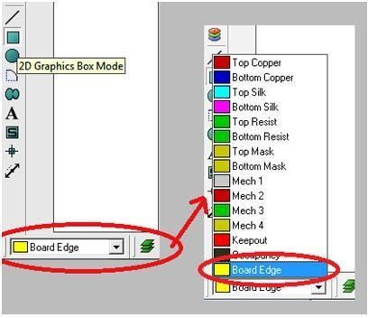

Fig no. 6.13 : selection of Board Edge

Then next click on work space then a green line will appear. With that draw a box and click again once. Then the box is fixed and turn into yellow color layout. This box is same like in above ISIS professional blue line. The circuit should be inside of the yellow box. If the circuit is more complex and big in size, the there is a chance to expand the box by clicking on the select mode. Then next click on the component name and change the angle of the component by using rotation arrow options if required. Then place the component on the work space.
After adding the all components to the work space, arrange the position of the components properly in the workspace. To move component one place to another place click on selection mode and click on component then it change color with white and hold the component and moved to required place within the yellow box. After placing the all components in correct position, next thing is tracking.
Tracking means establishing the connection between the components with copper layer. First select the track mode by clicking the track mode button, and change the track width by clicking ‘C’ create or ‘E’ edit buttons shown in the below image. When we click the button C or E immediately a window will open. Select the width of the track from given list. It is better to select between 25, 40.
Electronic hobbyists made their required PCB’s at their home or lab. At that time track width in case less than 25, there is a chance of occur cuts in tracks. The less width is useful in computer based PCB layering. So hobbyists are making their PCB’s their own. So the width should be greater than 25. My suggestion is the width should be 35.

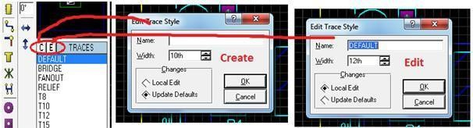

Fig no. 6.14 : Editing /selection of Trace stye
Then next thing is create tracks between components. Connection representation in green line and yellow line shows the direction. After setting the track width click at the component one end with pen and follow the green line. When two components are successfully connected then green line will removed automatically.
Another main thing is there are several PCB’s are available. Those are single layer PCB, duel layer PCB, multi layer PCB. In single layer PCB components are placed at one side and connections (tracking) done in another side.
Coming to duel layer PCB, tracking is done in two sides and components are placed in two sides also. In this type mostly SMD components are used. Next finally multi layered PCB’s, in these many layers are used. In this two are top and bottom layers and remaining all are inner layers. In Proteus we can design up to 16 layers PCB. One is top layer, another one is bottom layer and remaining all are inner layers. The layer selection in Proteus is at left down corner. Each layer will represent in different color. For example bottom layer represented in blue color, top layer represented in red and inner layers are represented in different colors. The image shown in below figure.
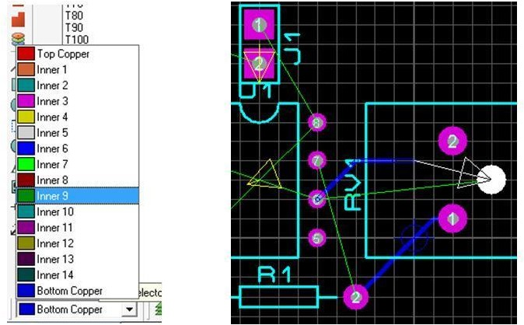

Fig no. 6.15 : selection of components

In the above image, it shows that track is placed between R1-2 pin and RV1-1pin. Another thing is placing the track from 6th pin to 3rd pin. The direction is indicating in white arrow mark. Connection is indicating in green line and blue line indicates the track. If any contact errors occurred
while tracking, those are represented in red circles and the image shown in below figure.
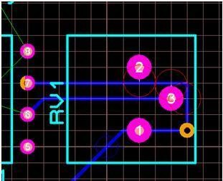

Fig no. 6.16: Indication of Errors
In the above image red color represented circles are errors occurred while tracking. To avoid such errors change the track path. Like this arrange the tracks between the all pins without errors. If you are planning for duel layer PCB, there is short cut for changing the track layers from one layer to another that is press the mouse left button two times immediately turned into another layer. In above image there is an orange circle. That represents the ‘via’ means placing connection between one layer to another layer. There is an advantage in Proteus. That is auto-router. This is special tool to arrange tracks automatically without errors. But this tool creates duel layer PCB. When we select this tool, automatically shape based auto router window will open. This window having the execution mode, design rules and grid width changing options. By changing all options according to our requirement and click the button begin routing automatically routing will start.
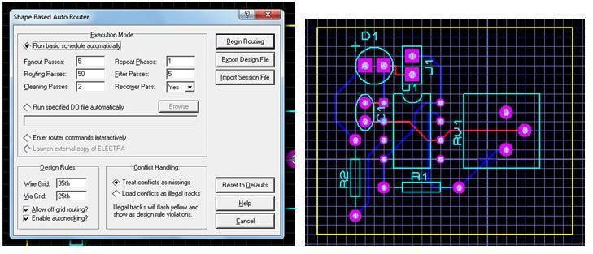

Fig no. 6.17 : Process of doing Routing

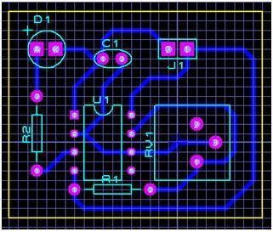
In above second image red tracks indicate top copper and blue tracks indicate bottom tracks. This is duel layer PCB designing. If we want single layer PCB, we can place tracks out own. The given below image shows the single layer PCB design of our required circuit. After completion of tracking save the project in same folder where the above Proteus project saved. In Proteus we have one other tool that how the circuit is been looking like after completion.

Fig no. 6.18 : Completion of PCB layout

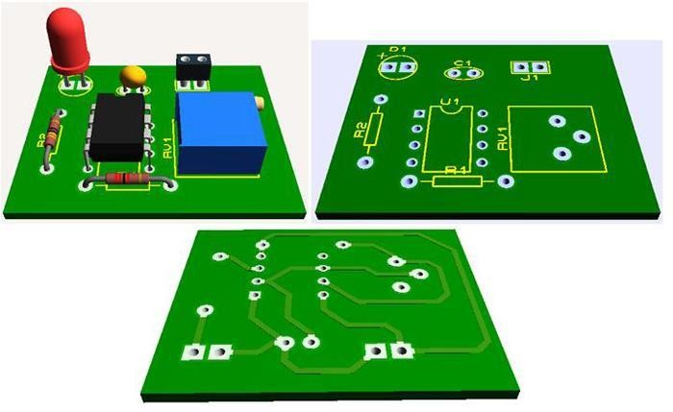
To see the final circuit, click on output in menu bar and then select 3D visualization. Then the circuit visualization will open in other window. It is having the features of all angles visualization, components less board view and back layer view. That is shown in below figure.

Fig no. 6.20 : 3D view of PCB layout

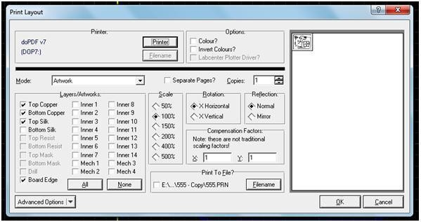
Next this is the final step of PCB layer designing, which is layout printing. Taking prints of board layer is the final step. So to take print of the circuit layout, click on output in menu bar and click on print. Then print layout setup window will open.
Fig no. 6.21 : Selection of PCB layout for printing

PROCESS OF ETCHING , DRILLING AND SOLDERING OF PCB:
PROCESS OF ETCHING OF PCB :
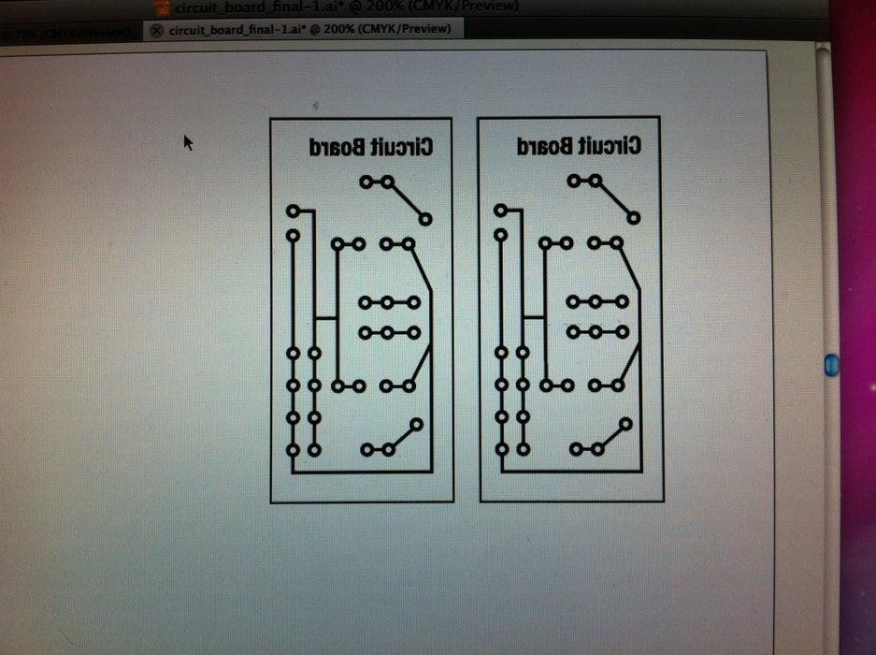
Step 1: Design First you need to design the board using a service like Eagle, Fritzing or you can even just use Adobe Illustrator if you know exactly what you want. And remember to flip the design once you have it complete before you print it out.
Fig no. 7.1 : print of PCB layout

Step 2: Print Out the Design Onto the Shiny Side of the Transfer Paper.
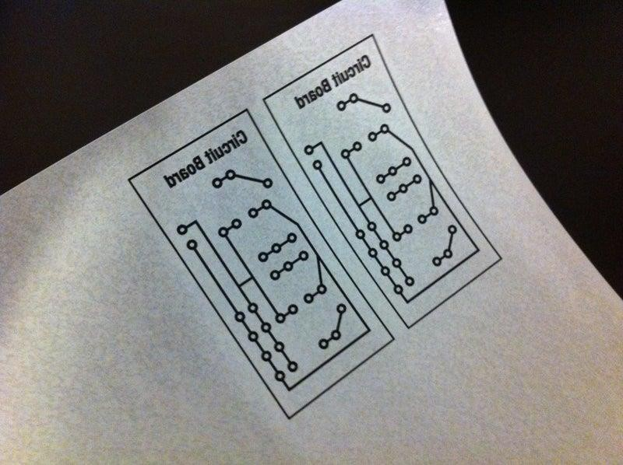
Fig no. 7.2 : Transferring the paper on shing Board

Step 3: Sand the Copper Plate So There Is a Rough Surface for the Design to Stick to When Transferred.

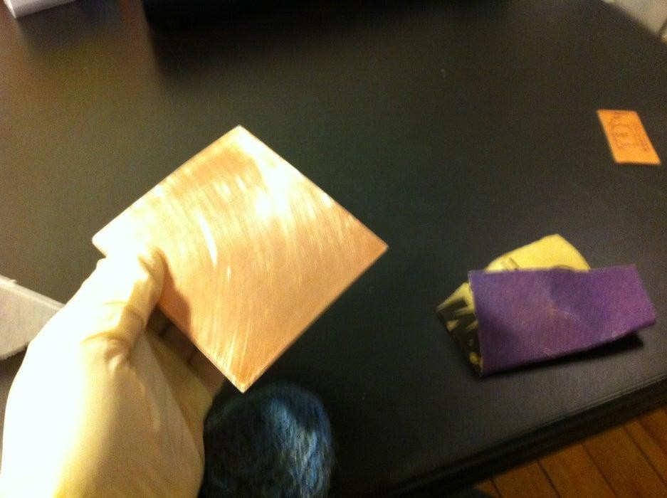
Fig no. 7.3 : Copper plate
Starting from this point on you should use surgical gloves to handle the copper plate and etching solution, this helps avoid getting oils on the copper and chemicals on your hands. When sanding do an extra good job on the edges.
Step 4: Wash the Copper With Some Water and Rubbing Alcohol and Let It Dry.
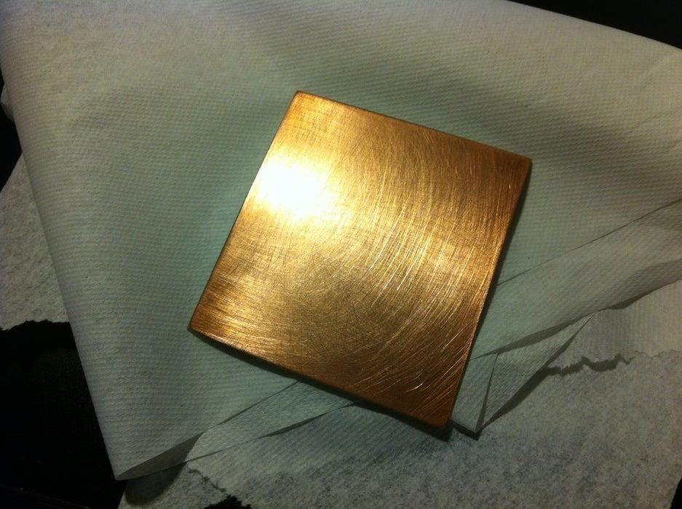
Fig no. 7.3 : washed board Step 5: Cut Out the Designs and Place Them Face Down on the Copper.

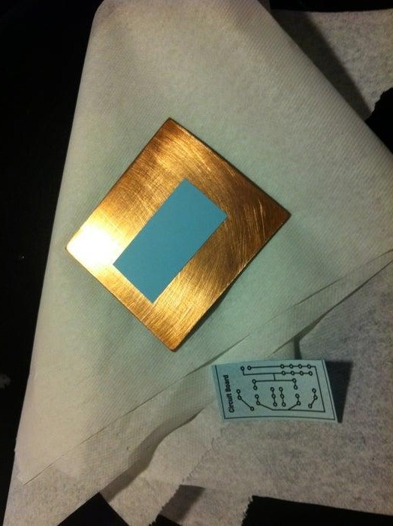
Fig no. 7.3 : sticking the PCB layout on board
Try and have some margins around the design this also helps the ink stick to the plate.

Step 6: Run the Copper Plate With the Design Face Down Through a Laminator 5-7 Times Until the Plate Is Hot.
You can also use a iron instead of a laminator if you don’t have one.
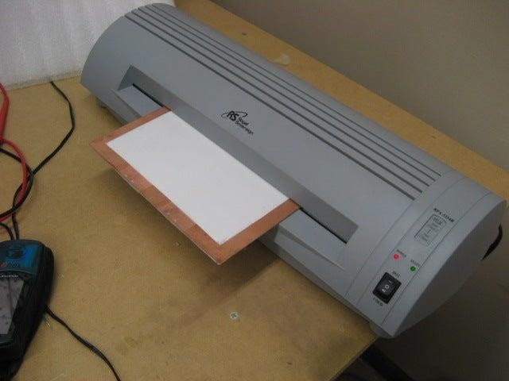

Fig no. 7.4 : Laminating the board

Step 7: After Running the Plate Through a Laminator or Iron Place the Plate Into a Cold Bath and Agitate Until the Paper Floats Off.

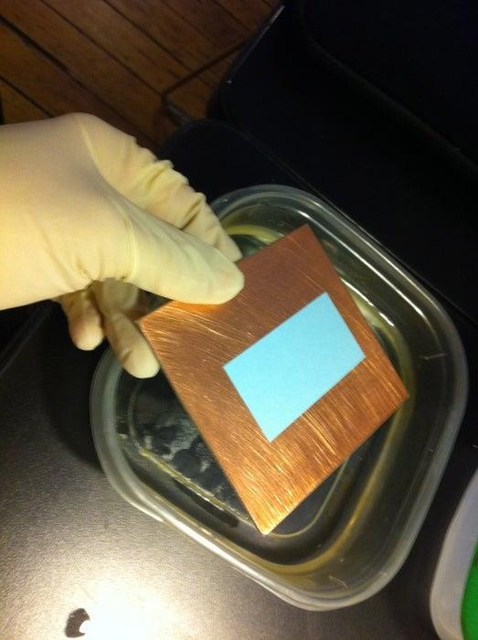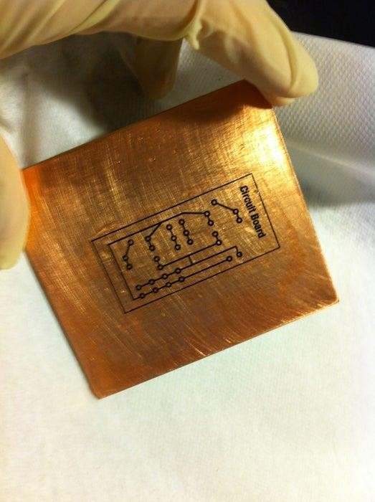
Fig no. 7.5 : washing the board with water
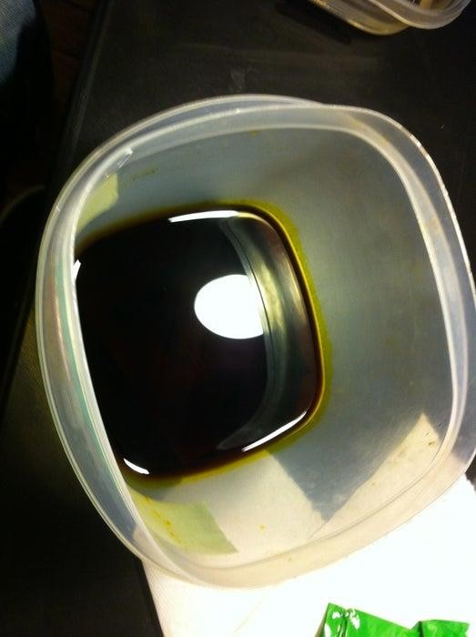
Step 8: Place the PCB Into the Etching Solution and Agitate for 25-30 Minutes or Until All the Copper Has Dissolved Around the Design.
Fig no. 7.6 : Etching the board into the Fecl3
If you would prefer not to agitate by hand here is another instructable I created on how to make a agitator using an old CD-ROM drive.

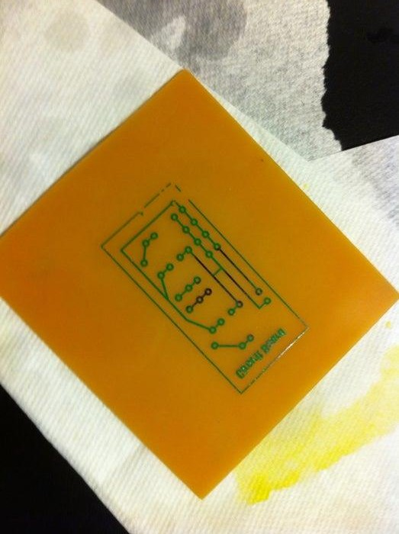
Step 9: Once All the Copper Is Gone Rinse It in the Water Bath, Let It Dry and Use Rubbing Alcohol to Whip Off the Ink Transfered Onto the PCB.
Fig no. 7.7 : Removing of copper from the plate
Step 10: And Now You Have a Etched PCB Board But You Still Need to Drill the Holes.
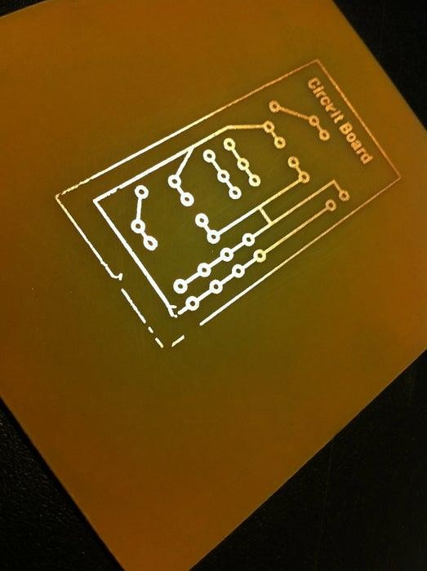
Fig no. 7.8 : Etched PCB

PROCESS OF DRILLING A PCB :
- The aspect ratio must be kept minimum to avoid drill wear.

- Higher the number of distinct drill sizes that are included in the design, higher will be the different drill bits that the manufacturer has to implement. Instead, if you reduce different drill sizes, the drill time will be cut down.
- Check if the non-plated drills have connections.
- Check for drill count/size between drill file and fab print.

- Check if drill type is defined as PTH or NPTH.

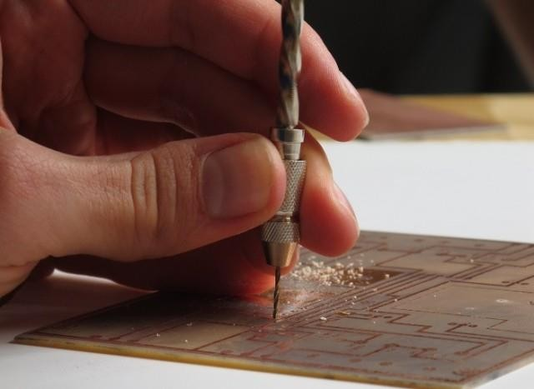

Fig no. 7.9 :drilling A Pcb
- Check for close holes less than 0.007″. If yes, it must be addressed (It can be spaced apart or one of the drill deleted if permitted).
- Check for mouse bites. Mouse bites are perforated breakaway tabs. They are a line of tiny holes in a PCB board just like the holes around a coupon. Mouse bites offer better grip when mounted.
- Check if the drills and other features on copper layers are falling outside the board profile.

- Prefer a minimum distance of 0.01” from hole edge to cutout/board profile.

- Check if the via size should be dropped to meet the minimum aspect ratio requirement after looking at the drill tolerance.
- For plated drills, the tolerance is less than +/- 0.002″ and NPTH the drill tolerance is of +/- 0.001.

- Fab drawing for arcs showing NPTH drill/slot or cut out locations but missing in the drill file.

- Check if the fab drawing for arcs show NPTH drill/slot or cut-out locations. Check if it reflects on the drill file.
- Mention the via sizes that need to be filled.

PROCESS OF SOLDERING A PCB :
Step 1: Prepare Your Iron :

Before you can use an iron to solder, you’ll want to complete a process known tinning. This process is all about coating the tip of the iron in solder to aid in the heat transfer process.
Begin this process by warming up the iron thoroughly and letting it rest until it reaches its full heat. Once it has completely heated, coat the tip thoroughly with solder, making sure to cover the entire tip. You’ll need to use plenty of solder to do so, and some of this will likely drip. Be prepared for this.Once you’re certain the entire tip is coated, wipe it off with a wet sponge to get rid of any excess flux residue. Do this right away, or else the flux may have time to solidify on the tip and become difficult to remove later.
Step 2: Prepare Your Surface :

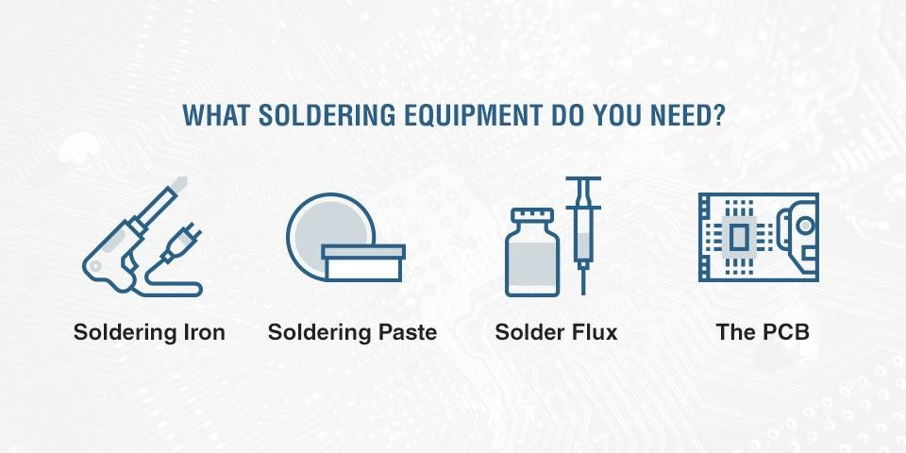
The key to a good soldering job is to start with a clean surface. To ensure your PCB board is clean and ready for soldering, use an industrial cleaning pad to wipe the surface clear of any dust and debris. You may also use an acetone cleaner to give it an additional wipe down. Finally, you might try giving it a few blasts of compressed air, as these will remove any small particles stuck in the board.

Fig no. 7.10 : Equipments required for soldering

Step 3: Place the Components :

Unless you’re working with an exceptionally simple circuit board, you’ll likely only be soldering one or two components at once, as opposed to doing the entire board in one session. We recommend starting with the smaller pieces and working up to the larger ones. This helps keep the board flat and balanced as the process begins, rather than weighing it down on one side with a single heavy piece.
Begin by selecting a few small components and placing them where they belong on the board. Bend the leads as you find you need to and insert the component into the holes where they belong. If you’re having trouble getting the piece to stay still once you aren’t holding it in place, try bending the leads so that they rest at a 45-degree angle along the bottom of the board.

Step 4: Apply Some Heat :

Add a very small amount of solder to the tip of the iron. This isn’t the solder that’s going to hold the components in place but is rather intended to conduct heat from the iron to the board.
To properly heat the joint, hold the iron so the tip touches both the board and the component lead. This positioning is critical since if the tip is in contact with only one of these pieces, the solder won’t stick. Once the tip is in position, the solder you applied earlier will make contact with both the lead and the board, heating them up and preparing them for the soldering. Hold the iron in position for a few moments before removing it.
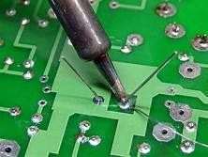
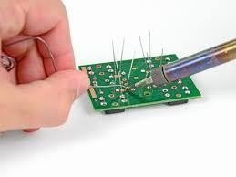
It’s possible to overheat during this stage, which you’ll want to avoid. If you notice the area starting to bubble, remove the heat immediately. Wait for it to cool and then heat it again, more cautiously this time.
Fig no. 7.11 : soldering the PCB

Step 5: Add Solder to the Joint :

Once you’ve heated the joint, you’re ready to solder. Begin by touching the tip of a strand of solder to the solder pad and lead. If you’ve heated this space correctly, the solder should flow freely and the flux should begin to liquefy and bubble. Keep adding solder around this joint until it’s entirely coated, forming a small mound. When you’ve reached this point, stop adding solder and remove your iron from the area, setting it aside.
As the joint cools, make sure it stays absolutely still. If you jostle it or allow it to move, the finish will look dull and grainy.
Step 6: Finish Up :
Once the joint has finished cooling, conduct a small inspection of it. If the solder joint looks good, move on
trimming the lead. You’ll do this by using side cutters to cut at the very top of the joint. From here, move on to the next component you want to solder in place. Once you’re finished with all your soldering for your current session, make sure to clean up any extra flux from the board, leaving you with a clean and finished products.

